Introduction
In recent years, polythiophenes and their corresponding finite model oilgomers, α-conjugated oligothiophenes have come to be increasingly appreciated as important objectives for study. The reason behind this aroused interest is due to their chemical stability in different oxidation states and their exceptional electronic properties. Also, the cyclic derivatives of polythiophenes with conjugated network can be considered equivalent to their infinitely long linear polymer with π-conjugation. They can be functionalized and improvised for applications in molecular electronic devices such as OLED’s, lasers or transistors.¹ Since these macrocycles have a cavity as well, they find applications in guest-host chemistry and specifically for anions which is also an upcoming field as anions play vital roles in a wide range of catalytic processes related to chemical and bio-chemical process.² Mono disperse linear π-conjugated oligomers of defined length and structure, considered as molecular wires, semi- conducting or metallic nanowires, or carbon nanotubes exceed the current resolution limits of nanolithography (100 Angstroms) and therefore represent ideal functional units for the mediation of electron transport and photonic processes.³ Such molecular entities will play a very crucial role in the development and evolution of building blocks for molecular scale electronics and nano devices. But for the realization of the concept of “nanoelectronics”, there is a vital need to develop molecular materials in nanoscale which can lead to fully functional circuits. Well-defined π-conjugated macrocycles are of interest as modular building blocks for the assembly of new materials and supramolecular architectures, not only because of their higher symmetry but also due to their toroidal structure, they could represent intriguing molecular circuits which would additionally include sites for recognition and selective complexation.⁴
In recent years, there has been increased focus on well defined macrocycles containing heterocyclic subunits. Many research groups have reported the synthesis and structural aspects of macrocycles with thiophene and oligothiophene subunits. Bauerle’s group has focused on development of novel synthetic methods for the preparation of multidimensional, functional π-conjugated materials and materials with self-organization properties.⁵ They reported the synthesis of cyclotrimer and cyclotetramer macrocycles, 1 and 2, containing oligothiophenes and diacetylenes as subunits by oxidative coupling of 5,5²-diethynyl-3,3²,4,4²-tetrabutylterthiophene under pseudo high-dilution conditions. Also, in one of their recent studies they have proposed a “metal templated approach” in which they have used Pt metal for synthesis of conjugated cyclo [8-18] thiophenes in higher yields. In this highly effective “one pot” synthesis, they converted alkylated quinquethiophene to stannylated intermediate via their corresponding dibromo derivative and further coupled with equimolar amounts of this Pt^{II} complex. The metal was removed by exchanging it with other ligands through reductive elimination of Pt with C-C bond formation to yield the desired macrocycles. In a parallel study, Iyoda’s group have investigated shape persistent π-expanded oligothiophenes,. The planarity of the macrocycles 3, 4, and 5 was sustained by thiophene, acetylene and ethylene units. Their synthetic approach comprised of Sonogashira and McMurry coupling reactions. These macrocyclic oligothiophenes were almost circular with 30-80 Å outer diameter and 18-60 Å inner cavities. The large size of these macrocycles resulted in weak amphiphilic properties and they formed microcrystals, nanowires and nanocrystals. Also, they illustrated the large nonlinear optical effects in these giant molecules which can be used as a tool for the studying two-photon properties.⁶ The macrocyclic oligothiophenes tend to attain saturation with respect to the energy of absorption in spite of increase in the number of heterocyclic units, due to the lack of effective conjugation between the adjacent thiophene units. A significant drawback of these macrocycles was the lack of effective conjugation in terms of ring current effects as expected for cyclic conjugated systems. We felt that such macrocyclic oligothiophenes could be better candidates for molecular electronics if they can be either aromatic or anti-aromatic in nature.
Objective of this project:
In this regard, we directed our efforts to synthesize macrocycles with multiple thiophene subunits stitched together by methylene carbons leading to a skeletal structure similar to that of anti-aromatic isophlorin, 6.⁷ The conjugation runs through the carbon atoms and resembles that of annulene. Novel isophlorins, 7 and 8, and expanded isophlorins, 9, 10 and 11, have been synthesized with different heterocyclic units such as thiophene and furan.⁸ The increase in conjugation led to significant decrease in the HOMO-LUMO gap as observed by electronic spectroscopy. They were found to be aromatic or anti-aromatic depending on the number of π electrons along the conjugated pathway. Invariably these macrocycles were found to be planar and also showed ring current effects in their ¹H NMR spectrum respectively. They also exhibit supramolecular interactions in the solid state through strong C-H…F-C hydrogen bonds. In fact such well defined supramolecular structures of planar anti-aromatic molecules encouraged us to explore the structural aspects of isophlorin like macrocycles with bithiophene units. Replacing the thiophene by bithiophene can double the number of π electrons in the macrocycle and also could lead to large macrocycles almost bearing the same number of thiophene subunits described for molecules 1-5. By incorporating more rigid oligothiophene units, the ring size could be enlarged along with concomitant increase in the conjugated path way. The other aspect of this project was also to develop simple synthetic methods by employing easy to make precursors.

Synthesis:
Invariably, thiophenes are well known to undergo oxidative coupling reactions, leading to polymeric products. Also, there are well-established synthetic methods to make length specific oligomers with definite number thiophene sub-units. Such thiophene oligomers can be easily functionalized by substituting with appropriate functional groups to generate easy to make precursors. Two different types of thiophene based precursors,⁸ bithiophene with two hydroxyl groups and oligomers with partially substituted terminal thiophenes (Scheme – 01), were synthesized to enable site specific condensation reactions. The unsubstituted bithiophene, 12, was converted to its dialcohol, 14, derivative by reducing the corresponding dialdehyde, 13, with pentafluorophenyl Grignard reagent. The electron withdrawing pentafluorophenyl was chosen as the substitutent to make the macrocycle electron deficient in nature. This could prevent probable ring oxidations of large π conjugated systems under ambient conditions. A thiophene and its oligomers in the form of dithiophene, 15, and trithiophene, 18, with two and three thiophene unitsstitched together by methyl carbons bearing pentafluorophenyl substitutent, were synthesized by two different methods. Thiophene reacts with pentafluorobenzaldehyde under acidic conditions to give 15 as the major product and the trithiophene and larger oligomers in poor yields. Therefore, thiophene was reacted with thiophene diol, 17 (derived from 16), to obtain 18 in good yields.
Our strategy was to utilize the acid catalysed condensation of alcohols with thiophene oligomers. The first target of our synthesis was the 24π 5,10,15,20-(tetrakis)pentafluorophenyl-21,22,23,24,25-pentathiaisophlorin, 19, and hence the bithiophene diol, 14, was condensed with trithiophene, 18, in dichloromethane under acidic (BF₃.OEt₂) conditions and later oxidized by ferric chloride (Scheme – 02). The reaction mixture was subjected to purification by column chromatography and three different products could be isolated. Apart from the expected 24π pentathiophene macrocycle (2.7% yield), two other macrocycles in the form of 38π 5,10,15,29,34,39-(hexakis)pentafluorophenyl-40,41,42,43,44,45,46,47-octathiaisophlorin, 20, and the 48π 5,10,15,20,34,39,44,49-(octakis)pentafluorophenyl-50,51,52,53,54,55,56,5,58,59-decathiaisophlorin, 21, were also isolated in poor yields. In order to increase the yields of the bigger macrocycles, we subjected the same reaction under concentrated conditions. It was observed that the 48π macrocycle, 21, was formed in better yield, while the other two smaller macrocycles were formed only in trace yields.

This led us to redesign our synthetic strategy so that we could exclusively synthesize 38π macrocycle. Therefore dithiophene, 15, was reacted with bithiophene diol, 14, under similar conditions to obtain the 38π octathiophene macrocycle in better yields. Reaction of thiophene with bithiophene diol, 14, under similar conditions led to the isolation of 28π 5,10,24,29-(tetrakis)pentafluorophenyl-30,31,32,33,34,35-hexathiaisophlorin (Scheme – 03). Most of these compounds were found to be non-polar in nature and hence repeated column chromatographic purification was required to isolate the macrocycles in their pure form. A plausible reaction mechanism for the formation these macrocycles is described in Scheme-04.
Spectral Characterization:
All the macrocycles described above were characterized by various analytical techniques before arriving at the final structure of these macrocycles. The molecular weight was confirmed by MALDI-TOF mass spectrometric analyses. 19, 20, 21, and 22 macrocycles showed m/z value at 1125.92, 1208.62, 1730.07 and 2251.93 against their calculated values at 1125.91, 1207.89, 1729.85 and 2251.81 respectively.
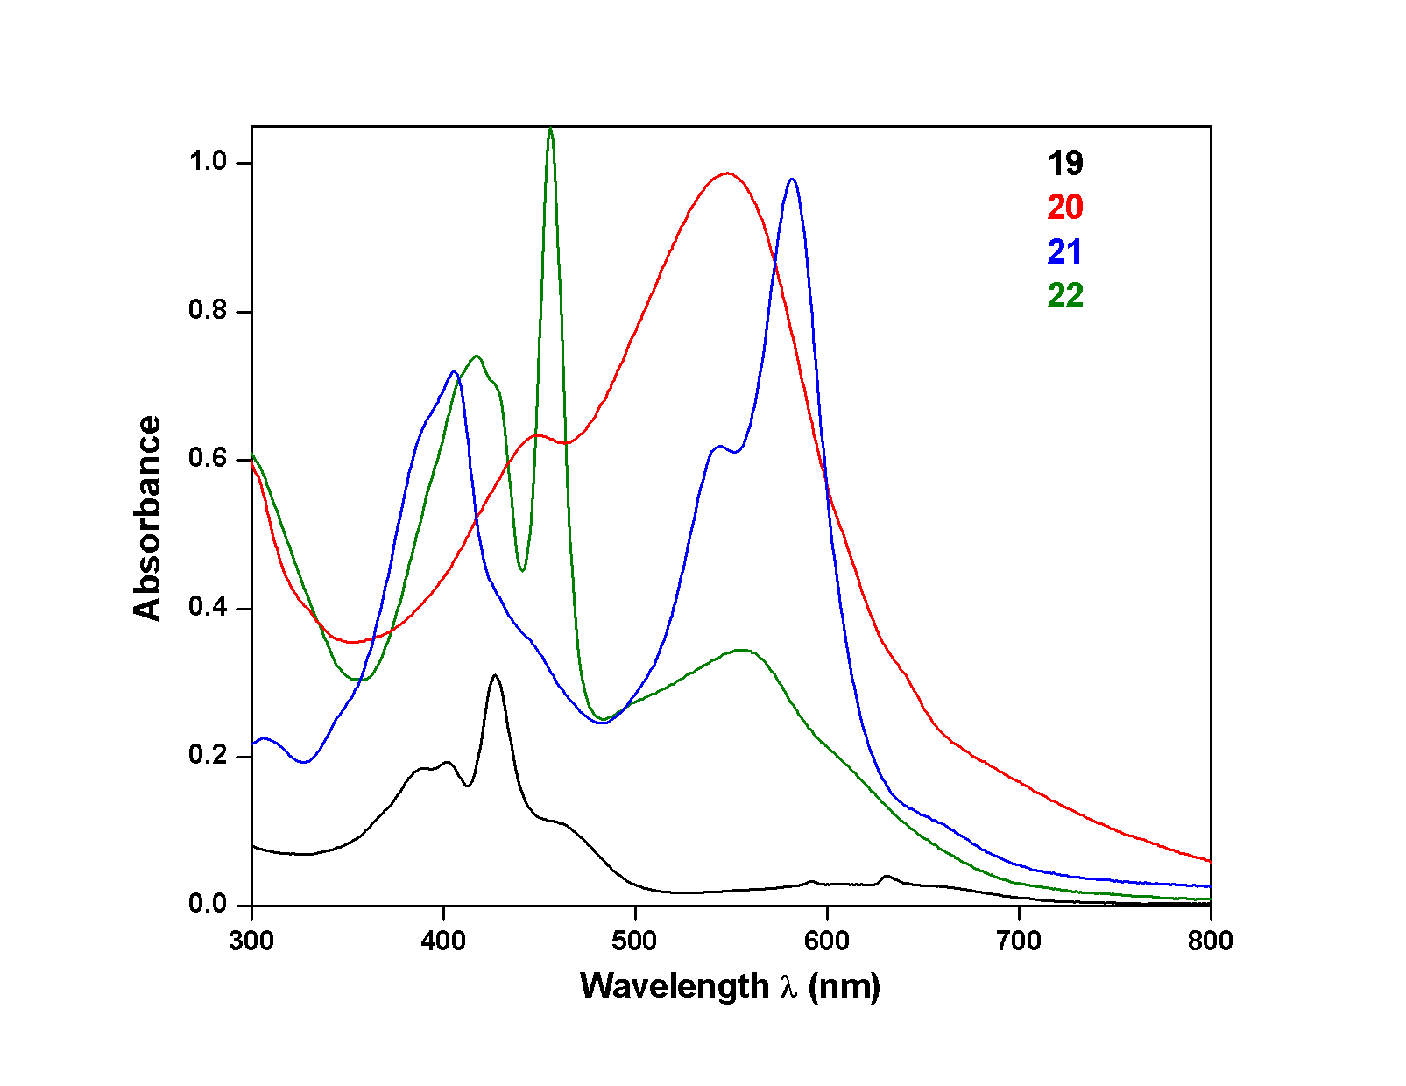

Figure-1: Electronic absorption spectra of 19, 20, 21, and 22 in dcichloromethane

Due to their extended conjugated system, they form colored solutions in common organic solvents. They were found to absorb in the visible region of the electromagnetic spectrum and show relative red shifts to justify the effective conjugation (Figure-1). Formally, the pentathia isophlorin 19 accounts for 24π electrons along its conjugated pathway and has its absorption maxima at 427 nm. It also shows split like absorption at 390 and 402 nm and a shoulder like absorption at 454 nm. The hexathia isophlorin, 22, accounts for 28π electrons along its conjugated pathway and forms pink colored solution in dichloromethane. It has absorption maxima at 456 nm and weakly absorbs at 418 nm with some low energy absorptions between 500 and 600 nm. The octathia isophlorin, 20, forms green colored solution in dichloromethane. It was found to have a maximum absorption at 548 nm and a shoulder like absorption at 453 nm. Similarly, the decathia isophlorin, 22, also formed pink colored solution in dichloromethane and was found to have absorption maxima at 582 nm along with a shoulder like absorption at 545 nm. The change in the absorption maxima can be correlated to the increase in the length of the conjugation upon insertion of more number of thiophene subunits (table-1). This also clearly indicates the effective π orbitals overlap of the adjacent π sub-units which leads to the comprehensive decrease in the energy gap between HOMO and LUMO of these macrocycles.

Macrocycle | No. of π electrons | λ_{max} (nm)
19 | 24 | 427
22 | 28 | 456
20 | 38 | 548
21 | 48 | 582
Table – 1: Comparison of absorption maxima with respect to number of π electrons

These macrocycles were also further characterized by ¹H NMR spectroscopy to deterimine their structure in the solution state. 19 shows a resolved spectrum in CDCl₃ at room temperature exhibiting five distinct signals. They were observed as triplets at δ 2.7 and 3.02 ppm, while a multiplet was observed at δ 4.17 ppm and two singlets were observed at δ 4.58 and 4.88 ppm. All these signals correspond to two protons each, accounting for all the ten protons from the five thiophene sub-units in the macrocycle. The signals for all the protons from the thiophene are upfield shifted compared to its unsubstituted counterpart. Since the 24π system is an anti-aromatic system, it is expected to show paratropic ring current effects and hence all the protons on the periphery of the ring are significantly upfield shifted. The nature of the spectrum indicates a C₂ symmetry passing the bithiophene bond and the centre of central thiophene in the trithiophene unit. The ring current effect induced upfield shifts of the proton signals justifies the planar nature of the macrocycle in solution state. The hexthia isophlorin, 22, also showed resolved spectrum in CDCl₃ at room temperature. Only three signals were observed, indicating the highly symmetrical nature of the macrocycle. Two doublets were observed at δ 7.75 and 7.25 ppm, while singlet like signal was observed at δ 4.3 ppm. All these signals were found to correspond to four protons each, thus accounting for all the twelve protons from the six thiophene rings. It is also corresponds to anti-aromatic systems since it accounts for formal 28π electrons along its conjugated pathway. The proton NMR of the octathia isophlorin, 20, could not be well resolved at room temperature. Even variable temperature NMR studies were indecisive about the nature of the resonances, since most of them appeared to be broad and hence could not be analyzed till date. Efforts are underway to obtain a well resolved ¹H NMR spectrum in different deuterated solvents.
Unlike 20, the decathia isophlorin, 21, exhibits a well resolved ¹H spectrum in CDCl₃ at room temperature. It exhibited five signals in the region between δ 6.2 to 7.1 ppm. Four doublets were observed at δ 7.05, 6.51, 6.3 and 6.24 ppm, while a singlet was observed at 6.4 ppm. Each signal corresponded to four protons each and hence accounted for all the twenty protons from the ten thiophene subunits in a macrocycle with a C₂ symmetry. Two doublets are assigned to the protons of the two bithiophene units, while the other two doublets are assigned to the protons of the four terminal thiophene of the trithiophene unit. The protons of the central thiophene of the trithiophene resonate as singlet. The spectrum does not clearly indicate any paratropic ring current effects as expected of 48π anti-aromatic system. In such a scenario the proton signals would have resonated in the upfield region for a planar macrocyclic system. Interestingly, a different set of five resonances were also observed in the same spectrum. Two doublets at δ 8.22 and 8.05 ppm corresponding to equal number of protons were observed along with three singlets at δ 10.11, 5.32 and 3.97 ppm. The integration value of these singlet resonances do not match for equal number of protons. The presence of these two different set of resonances indicates the possibility of two different conformations (planar and twisted) in solution state (scheme-05). We resorted to low temperature to confirm the possibility of two different conformers. But not significant change in the spectrum could be observed either at low temperature or at high temperature. The spectrum did not alter even in different NMR solvents. Further work is under progress to determine the solution state dynamics of this macrocyle both in experimental and theoretical studies as well.
We attempted to grow single crystals of these macrocycles to determine the absolute conformation in solid state. Good quality single crystals could be grown for 28π and the 48π anti-aromatic macrocycle. Selected crystallographic details are given in table-2. Good quality single crystals of hexathia isophlorin, 22, were grown from solvent mixture of CH₂Cl₂ and hexane and have tetragonal crystal system with P 4/ncc space group. It exhibits a planar and rectangular structure with all the sulfurs of the thiophene pointed towards the center of the macrocycle (figure-2). The pentafluorophenyl rings make an angle of 69º with the mean macrocyclic plane defined by the four methylene carbons. The C-C bond distances along the conjugated pathway of the macrocycle was found to be in between the single and double bond distances, conforming the delocalization of π electrons in the macrocycle. Further analysis of the crystal structure revealed inter molecular C-H…F-C interactions between the para fluorine of the all the pentafluorophenyl rings and the protons of the thiophene connecting the two bithiophene units. Each macrocycle has four pentafluorophenyl rings and para fluorine of all these rings act as hydrogen bond acceptors for the four β protons of the thiophene. Therefore each macrocycle has four hydrogen bond acceptors and four hydrogen bond donors. Overall, eight such interactions are observed between each macrocycle and its immediate four neighbours. All these interactions have the same parameters with bond distance (C6-H6…F3) of 2.71Å and a bond angle (C-H…F) of 170º. Such ordered structures are very rare in large macrocycles and hence they hold promise for easy fabrication required for applications in molecular electronics.

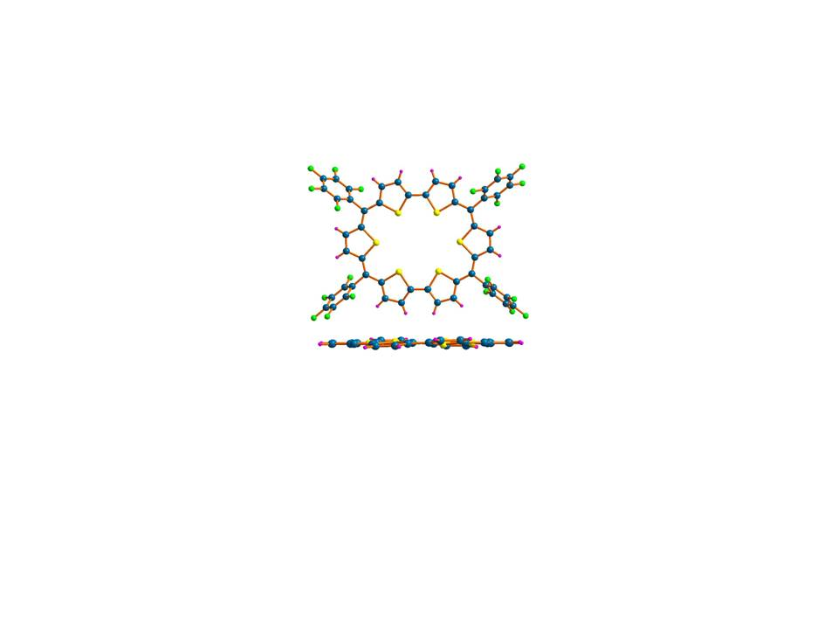

Figure – 2: Molecular structure of 22. The top view (above) and the side view (below). In the side view, pentafluorophenyl rings are omitted for clarity. Color code: C-blue; F-green; H-pink; S-yellow

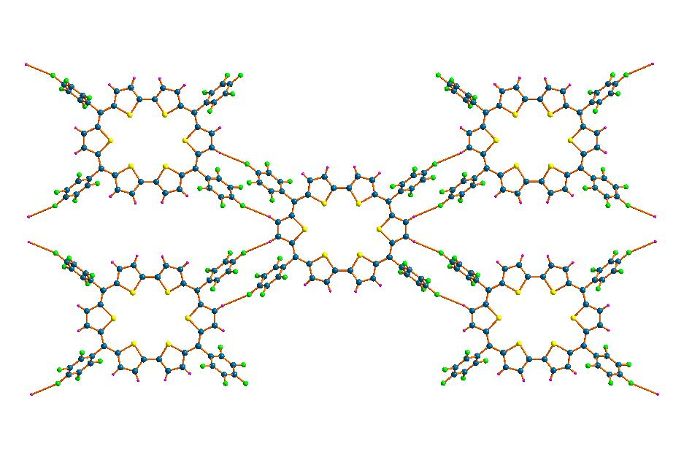
Figure – 3: Inter-molecular interactions involving C-H…F-C in 22. Pentafluorophenyl rings are omitted for clarity. Color codes are same mentioned for figure-2

Good quality single crystals could be grown for 21 from dichloromethane and hexanes. It was found have a monoclinic crystal system with C12/c1 space group. It has centre of symmetry and the unit cell contains exactly half of the exact macrocycle. The molecular structure as determined from x-ray diffraction was found to be a non-planar in nature (figure – 4). It shows a figure of eight conformation due the twist at the center of the molecule such that the two biothiophene units seem to overlap with each other. This also explains the absence of significant ring current effectsfor proton resonances in the ¹H NMR spectrum for 21. Therefore, the major conformer seems to be the non-planar and non-aromatic structure and hence leading to structure induced loss of paratropicity. This has also been observed earlier for large macrocycles,⁹ but for the first time it has been shown that such structural changes in macrocyclic oligothiophenes. The C-C bond length along the conjugated pathway is in between that of C-C double bond and triple bond. This clearly indicates the effective conjugation by the p orbital overlap, but the topology of the structure forces the macrocycle to become non-aromatic in nature.
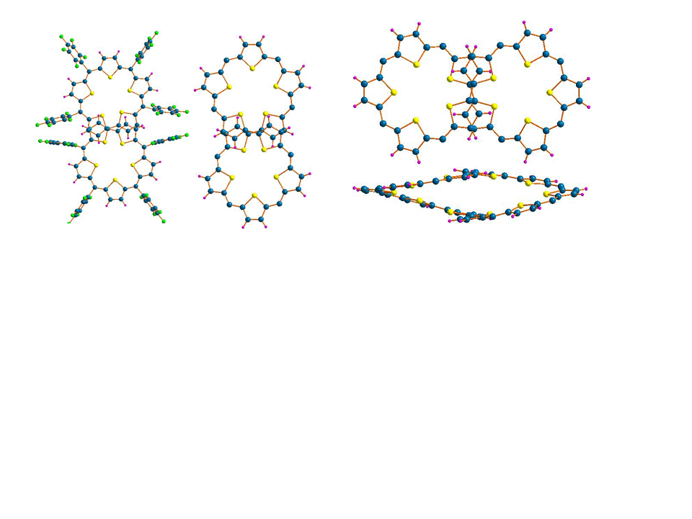

Figure – 4: Molecular structure of 21. The top view (above) and the side view (below). Pentafluorophenyl rings and solvent molecules are omitted for clarity. Color codes are the same as mentioned in figure-2.

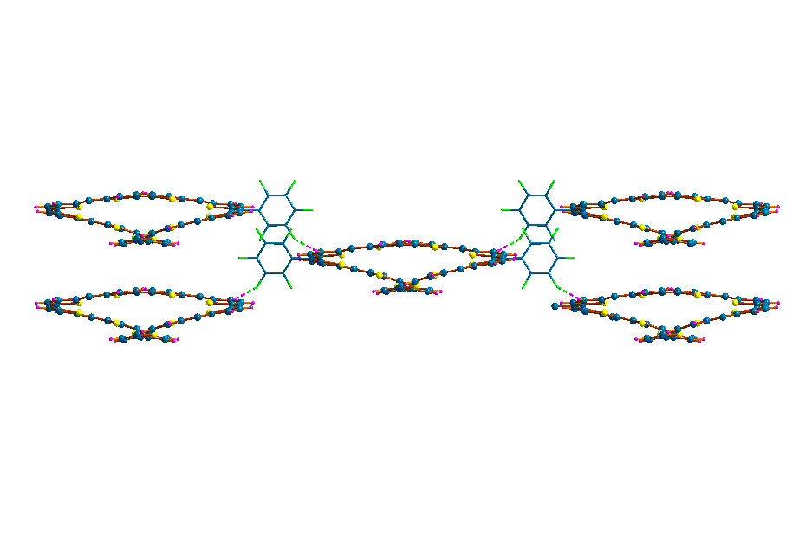Deeper analysis of the crystal structure revealed two different types of intermolecular C-H…F-C hydrogen bonds. Relatively a stronger interaction is observed when the meta fluorine of the pentafluorophenyl ring and hydrogen of the diagonally opposite terminal thiophenes of the trithiophene form C37-F11…H41-C41 (2.468Å, 150.3º) hydrogen bond. Each macrocycle has two such receptors and donors respectively and hence can connect to four different macrocycles in its immediate vicinity (figure-5).

Figure – 5: Intermolecular interactions involving C-F…H-C in 21. Only the pentafluorophenyl rings (wire frame work) involved in the interactions are shown for clarity. Color codes are the same as mentioned in figure-2.

The other hydrogen bond in addition to the above described, was observed from para fluorine of the pentafluorophenyl ring and the hydrogen of the terminal thiophene C20-F2…H27-C27 (2.522Å, 137.42º) leading to a dimmer like structure (figure – 6a). This dimmer like structure in association with the hydrogen bonds described in figure-5, forms a cyclic tetrameric structure (figure – 6b) and leading to a two dimensional network.
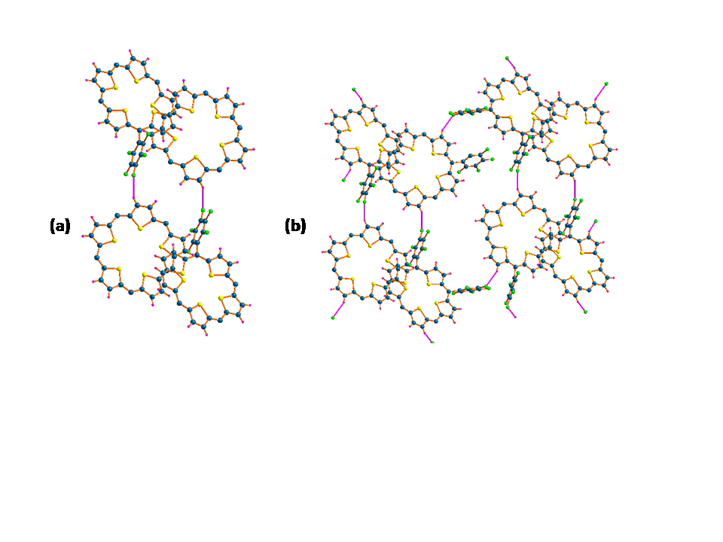

Figure – 6: Intermolecular interactions (a) dimmeric and (b) tetrameric structures involving C-F…H-C in 21. Only the pentafluorophenyl rings (wire frame work) involved in the interactions are shown for clarity.

A host of other interactions were also observed in the crystal structure, but most of them were found to be very weak in nature. A detailed analysis is underway the mine other possible non-covalent interactions in the solid state of 21. A point of concern that needs immediate attention is to identify the exact nature of the macrocycle in the solution state. Since two different set of resonances were observed, we are looking at possibility to stabilize both the conformers in solid state. Work is under progress to check the conformational control over the macrocycles with respect to key experimental parameters such as polarity of the solvent and temperature. A preliminary estimate of the ring size of 21 determined from the x-ray structure analysis turns to be 2 nm. With the aid of such strong intermolecular interaction, we hope to see well defined supramolecular structures of 21 under electron miscroscope. The morphology of such substances is expected to aid in the design and fabrication of these molecules for possible applications in molecular electronics.
Macrocycle | 21 | 22
Solvent System | CHCl₃/Hexane | CHCl₃/Hexane
Empirical formula | C₉₆H₂₀F₄₀S₁₀ | C₅₂H₁₂F₂₀S₆
Crystal System | monoclinic | tetragonal
Space group | C 1 2/c 1 | P 4/n c c
a | 40.811(3) Å | 11.791(4) Å
b | 7.4597(5) Å | 11.791(4) Å
c | 35.077(3) Å | 36.329(12) Å
α | 90.00 | 90.00
β | 105.702(10) | 90.00
γ | 90.00 | 90.00
V, Å³ | 10280.3(12) | 5051(3)
Z | 8 | 4
D_{calc} | 1.5247 g/cm⁻³ | 1.3415 g/cm⁻³
Abs. Coeff., | 0.336 | 0.228
F(000) | 4728 | 2028
Limiting | -48 ≤ h ≤ 51  -9 ≤ k ≤ 6  -43 ≤ l ≤ 44 | -8 ≤ h ≤ 6  -16 ≤ k ≤ 1 0  -21 ≤ l ≤ 50
Reflections Collected | 43624 | 10901
Independent reflections | 10738 | 3393
Absorption correction | multi-scan | multi-scan
GOF | 1.479 | 0.964
R1 | 0.1193 | 0.0886
R2_{w} | 0.3340 | 0.2226

Table – 2: Selected details of crystallographic data for 21 and 22
Summary:
In this project we have described the synthesis of four different novel macrocyclic oligothiophenes with isophlorin like skeleton. Our aim was to achieve the synthetic targets in less number of steps and from easy to make precursors. Also the condensation reactions were carried out under mild reaction conditions with air stable precursors. The strategy yielded serendipitous products, for which alternative synthetic design can evolve for exclusive synthesis of the hitherto unknown macrocycles. The spectral characterization clearly shows the ability of these molecules to have effective conjugation in macrocyclic environment. Electronic absorption spectroscopy reflects the relative decrease in the energy gap between HOMO and LUMO upon increasing the length of the conjugated pathway. Certainly these macrocyles have a better edge over the cyclo[n]thiophenes in electronic properties for potential application in molecular electronics. This is further exemplified by the molecular structures determined by single crystal diffraction studies. Their ability to form strong hydrogen bonds in a well arranged two dimensional fashion gives a positive outlook towards their fabrication as thin films or single crystals with directionality to electron mobility. Our plan to use pentafluorophenyl substitutent to prevent ring oxidation of macrocycles under ambient conditions also aids effective and strong intermolecular C-F…H-C hydrogen bonds. The probable presence of two different conformations in solution state, has offered an opportunity for topology dependent electronic properties of such macrocycles. A point of concern is the development of better synthetic methods or experimental conditions to encourage macrocycle formation by suppressing the more facile polymerization under acidic conditions.
In summary, the synthesis and characterization 19, 20, 21, and 22 have opened new avenues for tuning the electronic properties of macrocyclic oligothiophenes. This macrocycles can become easily accessible if the yields of these reactions can be increased. Their potential in molecular electronics needs to explored and is expected that they would be much better candidates than the existing thiophene based materials.

General Experimental Methods and Techniques

Chemicals for Syntheses:

Common solvents used for syntheses were purified according to known procedures. Thiophene was procured from Aldrich chemicals USA, and was distilled before use. Deuterated solvents for NMR measurements were used as received. n-Butyllithium (15% in hexane) were procured from E. Merck, Germany or Lancaster, UK. Anhydrous potassium carbonate, anhydrous sodium sulfate and anhydrous calcium chloride were obtained from RanKem Fine chemicals, India. Aluminum oxide (basic) and silica gel (100-200 and 230-400 mesh) were purchased from Acme chemicals, India. 2-Bromothiophene, pentafluoro benzaldehyde, pyridine-2,6-dicarbaldehyde, were used as received from Aldrich chemicals USA.

Physico-chemical techniques:

Instruments used for characterization and evaluation of spectroscopic data are discussed below.

Electronic spectra were recorded on a Perkin Elmer-Lambda 20 UV-Vis spectrophotometer. The data analyses were done using the UV-winlab software package. ¹H and ¹³C NMR spectra were obtained either from 500 MHz Bruker Advance DPX spectrometer or from 400 MHz Jeol machine either in CDCl₃ or in CD₂Cl₂. Chemical shifts are expressed in parts per million relative to residual CHCl₃/CH₂Cl₂. MALDITOF was carried out on Voyager-De-STR (Applied Biosystems). Single crystals were diffracted on Bruker Apex Duo single crystal x-ray diffractometer. The data was solved using Apex-2 software.

Synthesis of Precursor Compounds:

The schemes shown below show the schematic syntheses of various precursors. The details of synthesis and experimental details are given for important precursors used in the synthesis described in this thesis. Only NMR data is provided for molecules already reported in literature.

2,2'-Bithiophene: (12)

Activated Mg (1.5 g, 62 mmol) and dry THF (around 40 ml) and pinch of Iodine was stirred for 5-10minutes and color of solution changed to light brown. Then, 2-thiophene bromide (6ml, 62mmol) was added slowly and after sometime color of solution became colorless. Vigorous bubbling was observed and color changed to dark brown and most of the Mg turnings were found to be dissolved. Thiophene bromide (5.01ml, 51.6mmol) was added at 0⁰C and temperature was maintained. After that Ni(dpp)Cl₂ (0.336gm, 0.62mmol) was added as slowly as possible, as a suspension in THF. The solution mixture was allowed to come to room temperature and was refluxed at 90⁰C for 3hrs. The reaction was quenched with dil. HCl while keeping it in ice cold conditions as lot of heat was released. The organic layer was separated and the aqueous layer extracted with Et₂O (4 x 100 ml), dried over Na₂SO₄, and evaporated under reduce pressure. Then resulting mixture was chromatographed on silica (hexane). The desired product 12 was obtained as colorless viscous liquid. Yield 8.54 g (83%). ¹H NMR (400 MHz, CDCl₃) δ 7.22 (d, J = 5.7 Hz, 2H), 7.20 (d, J = 3.6 Hz, 2H), 7.03 (dd, J = 5.0, 3.6 Hz, 2H).
2,2'-Bithiophene-5,5'-dicarbaldehyde: (13)

A solution of n-BuLi (1.6 M in hexanes, 25 ml, 40 mmol) was added drop wise at –78 °C under Ar to a stirred solution of bithiophene (1.66 g, 10 mmol) in 100 ml of dry THF. During the whole addition, the reaction temperature was kept at –78 °C and then was allowed to gradually rise to –40 °C. At this temperature, DMF (6.1 ml, 80mmol) was slowly added and the reaction mixture allowed to warm to room temperature. The mixture was poured into a 2 M aqueous solution of ammonium chloride and extracted with CHCl₃ (5x50 ml). . The combined extracts were washed with water (3x50 ml), saturated brine, dried over Na₂SO₄, and evaporated under reduce pressure. The residue was recrystallized twice from CH₂Cl₂ to give 1.25 g (56 %) of desired product as yellow crystals. ¹H NMR (400 MHz, CDCl₃) δ 9.91 (s, 2H), 7.73 (d, J = 4.0 Hz, 2H), 7.42 (d, J = 4.0 Hz, 2H).
2,2'-bithiophene-5,5'-diylbis((perfluorophenyl)methanol): (14)

Dry THF (25ml) and activated Mg (0.169 g, 6.95 mmol) and pinch of iodine was stirred for 2 minutes. After that pentafluorobromide (0.859 ml, 6.7 mmol) was added slowly and color of solution became dark brown and was allowed to stir for two hours. To the Grignard of pentaflorobromide was added the aldehyde dissolved in THF at 0⁰C and allowed to reach room temperature. Then TLC was checked and dipped in DNPH to check if any aldehyde is left or not. Then reaction mixture was quenched after 3 hours and the organic layer was extracted with Et₂O and combined organic layer was washed with water and brine solution. After drying over Na₂SO₄, the solvent was evaporated under vacuum to yield the pure compound, as white solid. Yield: 62%. ¹H NMR (400 MHz, CDCl₃) δ 6.98 (d, J = 3.7 Hz, 2H), 6.80 (d, J = 3.7 Hz, 2H), 6.34 (d, J = 6.0 Hz, 2H), 2.97 (d, J = 7.4 Hz, 2H).
2,2’-((pentafluorophenyl)methylene)dithiophene: (15)

A mixture of thiophene (200 mmol, 15.7 ml) and pentafluoro benzaldehyde (10 mmol, 1.2 ml) was degassed by bubbling with argon for 10 min. BF₃ .Et₂O (10 mmol, 1 ml) was added and the mixture was stirred for 30 minutes at room temperature. It was diluted with dichloromethane (100 ml), and then washed with 0.1N NaOH, followed by water washing. The organic layer was dried over anhydrous Na₂SO₄. The solvent was removed under reduced pressure and the unreacted thiophene was removed by vacuum distillation. The resulting viscous dark yellow liquid was purified by column chromatography (silica gel 100-200 mesh) using only hexane as eluant. Product was isolated as white solid in 80% yield.
2,5-di-formylthiophene: (16)

Dilithiated thiophene was prepared by the addition of butyllithium (59.42 mmol, 38.0 ml) at room temperature to a mixture of TMEDA (59.42 mmol, 9.0 ml) and thiophene (23.7 mmol, 1.9 ml) in n-hexane (40 ml). The temperature of the mixture was raised to 50ºC and the conversion was completed by refluxing the mixture for 30 min. Then, THF (20 ml) was added, the solution was cooled to -40ºC and excess DMF (71.1 mmol, 6.0 ml) was added over a 10 min. period. The temperature of the system was gradually raised to room temperature and stirring was continued for 30 min. The suspension was then poured into a mixture of 30% HCl (50 ml) and H₂O (150 ml) at -20ºC under vigorous stirring. Part of the aldehyde separated during this hydrolysis. Saturated NaHCO₃ solution was slowly added until the aqueous layer had reached pH 6. The organic layer was separated and the aqueous layer extracted with Et₂O (7 x 50 ml). The organic solution was dried over MgSO₄, the solvent removed in vacuum, and the product crystallized from THF/ Et₂O (4:1) to afford pure product as light yellow solid. Yield: 62%. ¹H NMR (400 MHz, CDCl₃) δ 10.04 (s, 2H), 7.84 (s, 2H).

2,5-bis(pentafluorophenylhydroxymethyl) thiophene: (17)
To a stirred solution of 2,5-diformylthiophene, 16, (7.5 mmol, 1.05 gm in 15 ml THF) under argon atmosphere at 0ºC, freshly prepared Grignard reagent (C₆F₅MgBr, 15 mmol) was added Stirring was continued for 3hrs to attain room temperature, the reaction mixture was quenched with saturated NH₄Cl solution. The organic layer was extracted with Et₂O and combined organic layer was washed with water and brine solution. After drying over Na₂SO₄, the solvent was evaporated under vacuum to yield the pure compound, as white solid. Yield: 65%. ¹H NMR (400 MHz, CDCl₃) δ 6.76 (s, 2H), 6.33 (d, J = 8.3 Hz, 2H), 2.88 (d, J = 8.3 Hz, 2H).
2,5-bis((perfluorophenyl)(thiophen-2-yl)methyl)thiophene: (18)

A mixture of 2,5-(pentafluorophenylhydroxymethyl) thiophene, (238 mg, 0.5 mmol) and thiophene (3.0 ml, 37 mmol) was degassed with argon for 10 min, then BF₃.O(Et)₂ (0.06 ml, 0.5 mmol) was added. The resulting solution was stirred at room temperature for 30 min and then poured in to CH₂Cl₂ (50 ml) and neutralized by aqueous NaOH (0.1N). The organic layer was washed with water and dried over MgSO₄. The excess thiophene and solvent was removed in vacuum and resulting solid was chromatographed on silica (1% ethyl acetate in hexane) the desired product was obtained as light yellow solid. Yield 216 mg. ¹H NMR (400 MHz, CDCl₃) δ (71%). δ 7.25 – 7.21 (m, 4H), 6.97 – 6.91 (m, 2H), 6.77 (s, 2H), 6.14 (s, 2H).

Synthesis of 19, 20 and 21:

An equimolar concentration of bithiophene diol, 14, (200mg, 0.35 mmol) and 18 (2,5-bis((perfluorophenyl)(thiophen-2-yl)methyl)thiophene) (218 mg, 0.35 mmol) were mixed in 20 ml of dry DCM under innert atmosphere. They were condensed with equimolar concentrations, with BF₃.OEt₂ (4.39x10⁻² ml, 0.35mmol) as the catalyst, and was stirred for 2 hrs in dark. Further, reaction mixture was oxidized by DDQ (0.198 mg, 0.895 mmol) and left for stirring for approximately 2 hrs. Then 3-4 drops of triethylamine were added for the neutralization and work up was done using a basic alumina column. Finally, using column chromatographic purification yielded 19 and 21 in 2.65% and 13% yields respectively. Trace amounts of 20 was also formed, but could not be purified from column chromatography.
Select data for 19: ¹H NMR (400 MHz, CDCl₃) δ 4.89 (s, 2H), 4.58 (s, 2H), 4.18 (q, J = 7.1 Hz, 2H), 3.03 (t, J = 6.4 Hz, 2H), 2.69 (t, J = 6.3 Hz, 2H). MALDI-TOF Mass m/z: Calcd For C₄₈H₁₀F₂₀S₅: 1125.91 (100.0%); Observed: 1125.92(100.0%, M +1).
Select data for 21: ¹H NMR (400 MHz, CDCl₃) δ 7.06 (d, 3.68 Hz, 4H), 6.52 (d, 3.68 Hz, 4H), 6.4 (s, 4H), 6.3 (d, 5.88 Hz, 4H), 6.25 (d, 5.88 Hz, 4H) MALDI-TOF Mass m/z: Calcd For C₉₆H₂₀F₄₀S₁₀: 2252.82 (100.0%); Observed: 2251.92(100.0%, M +1).

Synthesis of 20:
Equimolar concentration of (2,2'-bithiophene-5,5'-diylbis((perfluorophenyl)methanol), 14, (150 mg, 0.268 mmol) and with, 2,2’-((pentafluorophenyl)methylene)dithiophene, 15, (93 mg, 0.268 mmol) were stirred 150 ml of dry DCM under inert atmosphere. They were condensed with equimolar concentrations, with BF₃.OEt₂ (3.37x10⁻² ml, 0.268 mmol) as the catalyst and was stirred for 2 hrs in dark. Further, reaction mixture was oxidized by DDQ (152mg, 0.67mmol) and left for stirring for 2 hrs. Then 3-4 drops of triethylamine were added for the neutralization and work up was done using a basic alumina column. Finally, silica gel column chromatographic purification yielded 21 in 7% yields.
Synthesis of 22
An equimolar concentration of bithiophene diol, 14, (150 mg, 0.268 mmol) with, thiophene (2.121x10⁻² ml, 0.268 mmol) was mixed in 150 ml of dry DCM. They were condensed in equimolar concentrations, with BF₃.OEt₂ (3.37x10⁻² ml, 0.268 mmol) as the catalyst and was stirred for 2 hrs. Further, reaction mixture was oxidized by DDQ (152 mg, 0.67 mmol) and left for stirring for approximately 2 hrs. Then 3-4 drops of triethylamine were added for the neutralization and work up was done using a basic alumina. Finally, using silica gel column chromatographic purification yielded 22 in 6% yields.
Select data for 22: ¹H NMR (400 MHz, CHLOROFORM-D) δ 7.71 (dd, J = 5.7, 3.5 Hz, 4H), 7.53 (dd, J = 5.6, 3.3 Hz, 4H). MALDI-TOF Mass m/z: Calcd For C₅₂H₁₂F₂₀S₆: 1207.89 (100.0%); Observed: 1208.62(100.0%, M +1).

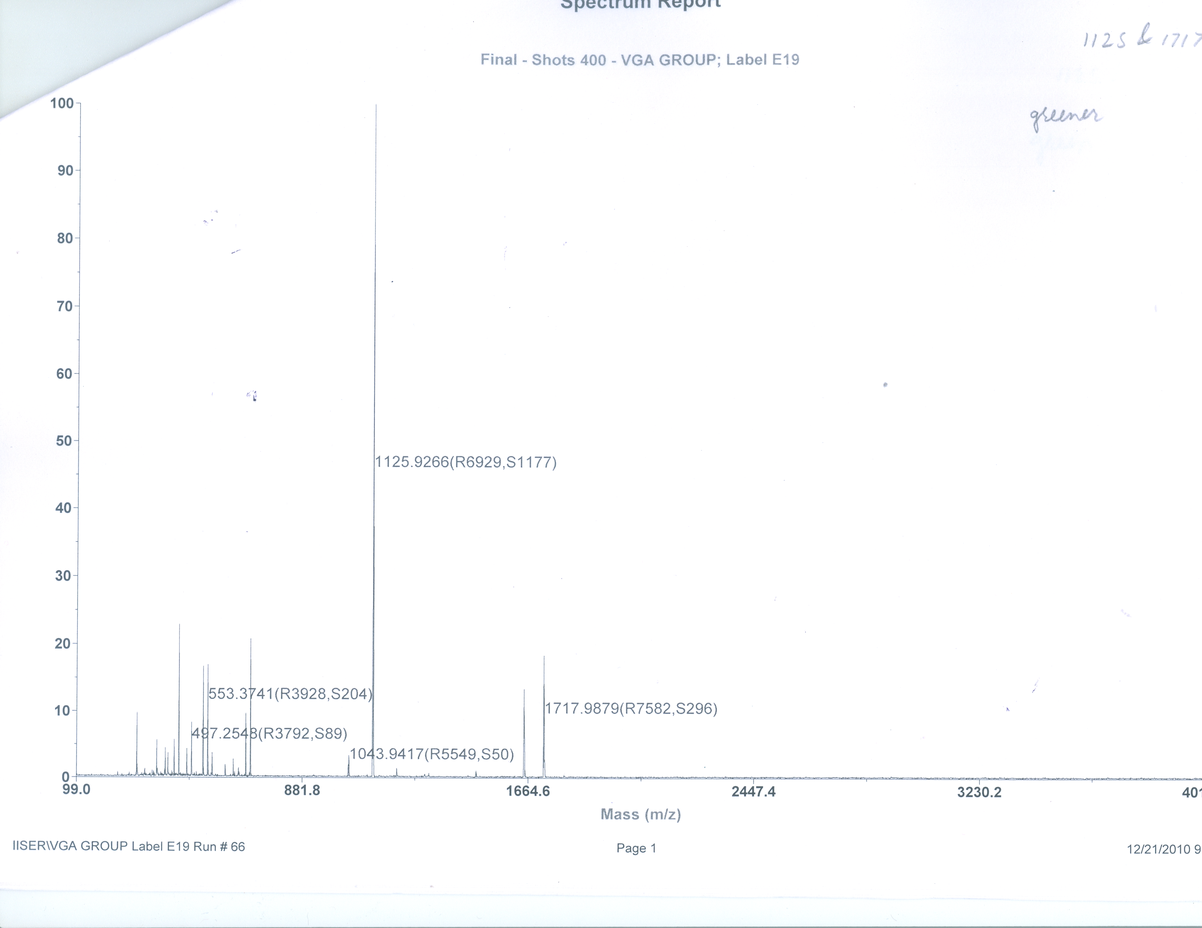

Figure – 7: Maldi-Tof spectrum of 19.

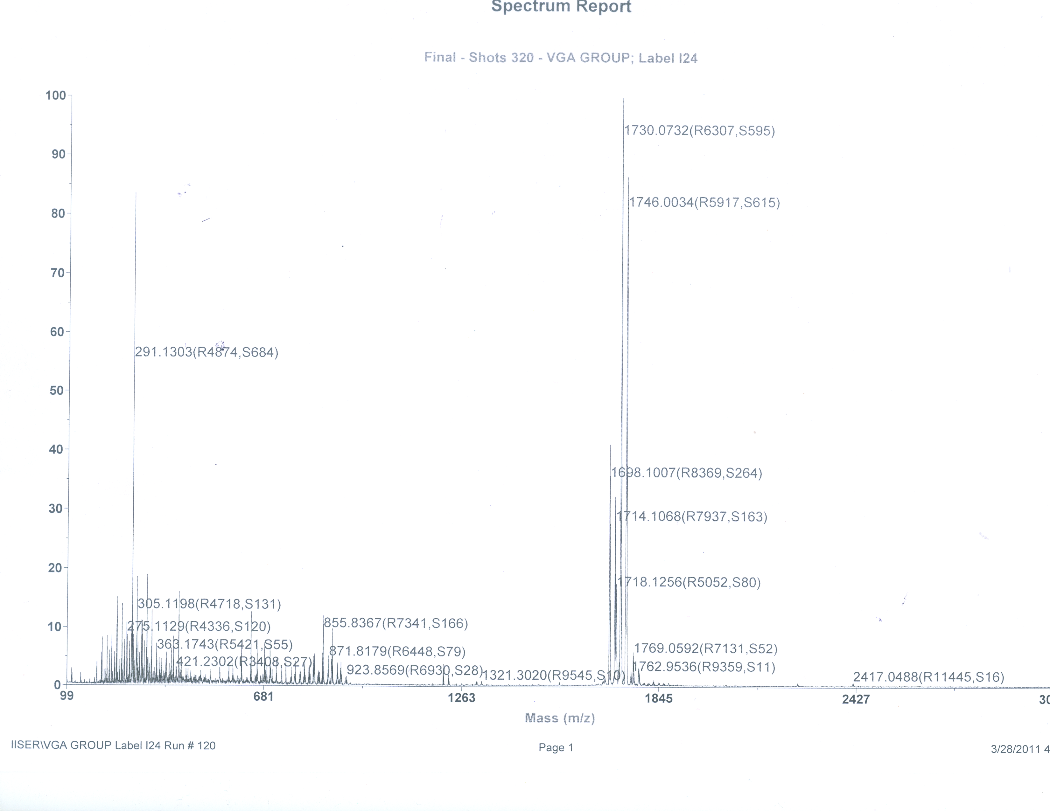

Figure – 8: Maldi-Tof spectrum of 20.

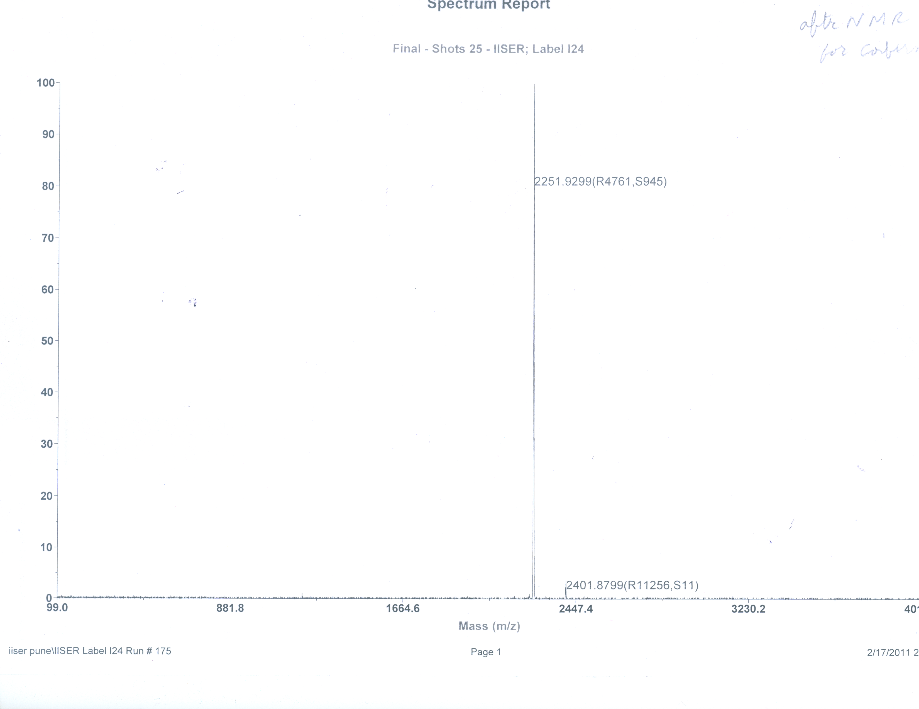

Figure – 9: Maldi-Tof spectrum of 21.

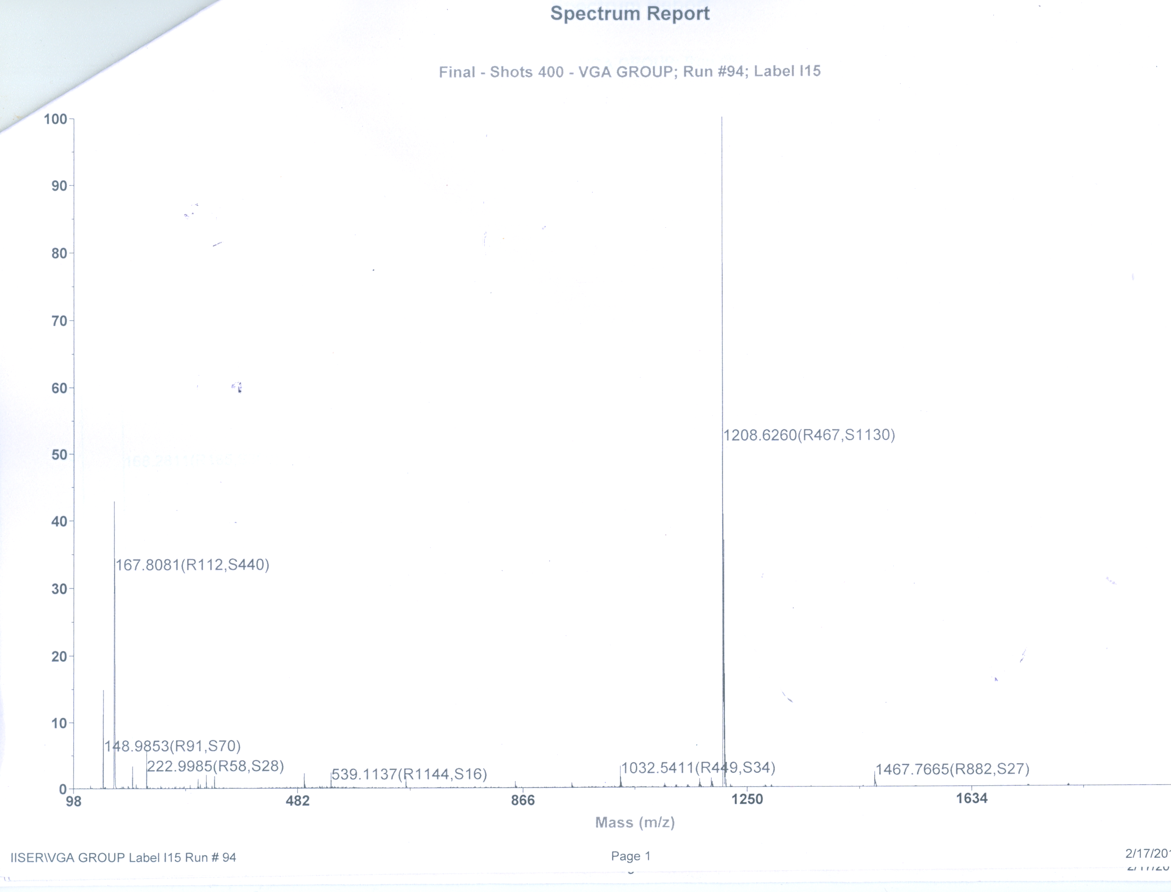

Figure – 10: Maldi-Tof spectrum of 22.

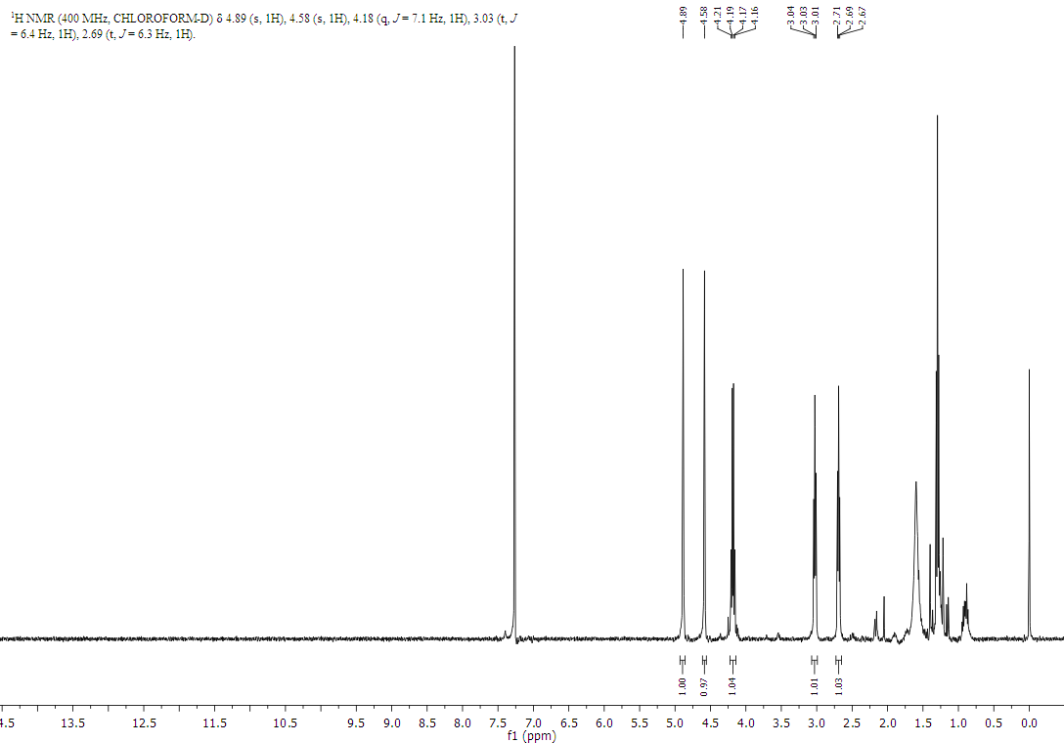
Figure – 11: ¹H NMR spectrum of 19.

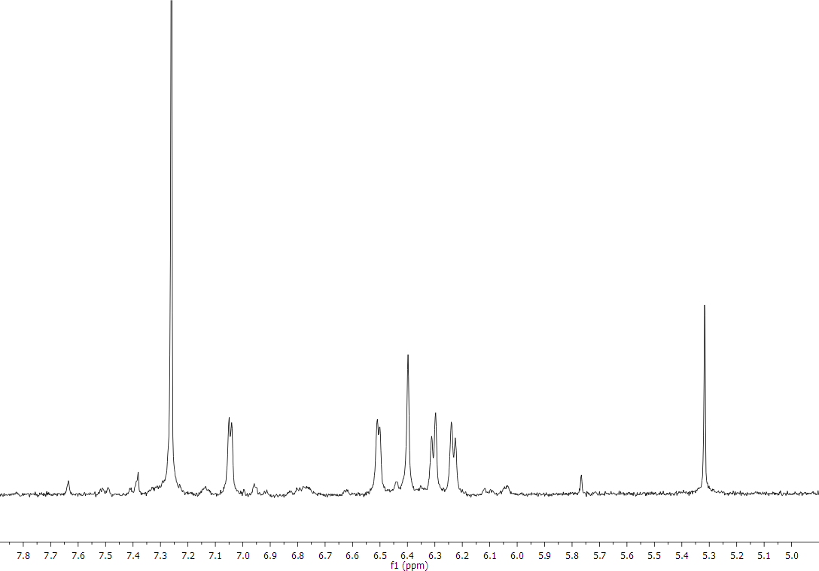
Figure – 12: Partial ¹H NMR spectrum of 21.

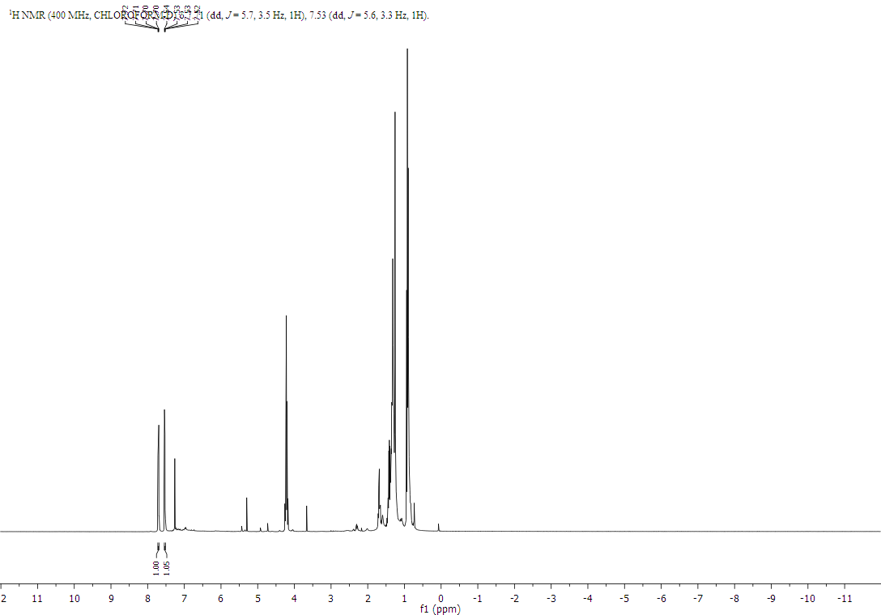
Figure – 13: Partial ¹H NMR spectrum of 22.

References:
- Handbook of Oligo- and polythiophenes (Ed.: D. Fichou), WileyVCH, Weinheim;1999.
- a) J. Roncali, Acc. Chem. Res. 2000, 33, 147. b) N. Aratani, A. Osuka, Y. H. Kim, D. H. Jeong, D. Kim, Angew. Chem. Int. Ed. 2000, 39, 1458. c) R. E. Martin, F. Diederich, Angew. Chem. Int. Ed. 1999, 38, 1350. d) Electronic Materials: The Oligomer Approach (Eds: K. Müllen, G. Wegner), WILEYVCH, Weinheim 1998. e) W. B. Davies, W. A. Svec, M. A. Ratner, M. R. Wasielewski, Nature 1998, 396, 60. f) J. Tour, Chem. Rev. 1996, 96, 537.
- a) J. Muster, G. T. Kim, V. Krstic, J. G. Park, Y. W. Park, S. Roth, M. Burghard, Adv. Mater. 2000, 12, 420. b) D. Xu, Y. Xu, D. Chen, G. Guo, L. Gui, Y. Tang, Adv.Mater. 2000, 12, 520. T. S.Mayer, Adv. Mater. 1999, 11, 1021.
- a) H. Engelkamp, S. Middelbeek, R. J. M. Nolte, Science 1999, 284, 785, b) D. M. Kolb, G. E. Engelmann, Angew. Chem. Int. Ed. 2000, 39, 1166. c) L. Chi, S. Jacobi, B. Anczykowski, M. Overs, H.-J.Schäfer, H. Fuchs, Adv. Mater. 2000, 12, 25.
- a) F. Zhang, G. Götz, H. D. F. Winkler, C. A. Schalley, P. Bäuerle. Angew. Chem., Int. Ed. 2009, 48, 6632; b) A. Mishra, C.-Q. Ma, P. Bäuerle, Chem. Rev. 2009, 109, 1141-1278: Functional Oligothiophenes: c) L. Krömer, I. Rios-Carreras, G. Fuhrmann, C. Musch, M. Wunderlin, T. Debaerdemaeker, E. Mena-Osteritz, P. Bäuerle. Angew. Chem., Int. Ed. 2000, 39, 348; d) G. Fuhrmann,L. Krömer, P. Bäuerle. Synth. Met. 2001, 119, 125; e) E. Mena-Osteritz, P. Bäuerle. Adv. Mater. 2001, 13, 243.
- Nakao, K.; Nishimura, M.; Tamachi, T.; Kuwatani, Y.; Miyasaka, H.; Nishinaga, T.; Iyoda, M. J. Am. Chem. Soc. 2006, 128, 16740. Iyoda, M. Heteroat. Chem. 2007, 18, 460. Williams-Harry, M.; Bhaskar, A.; Ramakrishna, G.; Goodson, T.; Imamura, M.; Mawatari, A.; Nakao, K.; Enozawa, H.; Nishinaga, T.; Iyoda, M. J. Am. Chem. Soc. 2008, 130, 3252.
- (a) Woodward, R. B. Total synthesis of chlorophylls. Angewandte Chemie. 1960, 72, 651. (b) Woodward, R. B.; Ayer, W. A.; Beaton, J. M.; Bickelhaupt, F.; Bonnett, R.; Buchschacher, P.; Closs, G. L.; Dutler, H.; Hannah, J.; Hauck, F. P.; Ito, S.; Langemann, A.; Goff, E. L.; Leimgruber, W.; Lwowski, W.; Sauer, J.; Valenta, Z.; Volz, H. The total synthesis of Chlorophyll a. Tetrahedron, 1990, 46, 7599. (c) Pohl, M.; Schmickler, H.; Lex, J.; Vogel, E. Isophlorins: Molecules at the crossroads of Porphyrin and Annulene Chemistry. Angew. Chem. Int. Ed. Engl. 1991, 30, 1693.
- (a) Reddy, J. S.; Anand, V. G. Planar Meso Pentafluorophenyl Core Modified Isophlorins. J. Am. Chem. Soc. 2008, 130, 3718. (b) Reddy, J. S.; Mandal, S.; Anand, V. G. Cyclic Oligofurans: One-pot synthesis of 30π and 40π expanded porphyrinoids. Org. Lett. 2006, 24, 5541. (c) Reddy, J. S.; Anand, V. G. Aromatic Expanded Isophlorins: Stable 30π Annulene Analogues with Diverse Structural Features. J. Am. Chem. Soc. 2009, 131, 15433.
- Vogel, E. The porphyrins from the “annulene chemist’s’ perspective. Pure & Appl. Chem. 1993, 65, 143.

