Prediction and Validation of potential residues that drive allostery in myosin head domain

A thesis submitted towards partial fulfilment of the requirements of BS-MS Dual Degree Program



By
Shekhar Jadhav
20141129
Under the guidance of
Prof. Mohan Balasubramanian
Warwick Medical School, University of Warwick
and
Dr. Gayathri Pananghat
Department of Biology
Indian Institute of Science Education and Research (IISER), Pune
Fifth year MS Thesis – Mid Year Report

Thesis Advisor: Dr. Chaitanya Athale, IISER Pune

Certificate

This is to certify that this dissertation entitled “Prediction and validation of potential residues performing crucial role in allosteric conformational changes in myosin head domain” towards the partial fulfilment of the BS-MS dual degree programme at the Indian Institute of Science Education and Research, Pune represents study/work carried out by Shekhar Sanjay Jadhav under the supervision of Prof. Mohan Balasubramanian, Professor, Warwick Medical School, University of Warwick and Dr. Gayathri Pananghat, Assistant Professor, Department of Biology, IISER Pune during the academic year 2018-2019

Prof. Mohan Balasubramanian Dr. Gayathri Pananghat

Professor Assistant Professor

Warwick Medical School Department of Biology

University of Warwick IISER Pune

Date 20th March 2019

Declaration

I hereby declare that the matter embodied in the report entitled “Prediction and validation of potential residues performing crucial role in allosteric conformational changes in myosin head domain” are the results of the work carried out by me at the Warwick Medical School, University of Warwick and Department of Biology, IISER Pune under the supervision of Prof. Mohan Balasubramanian and Dr. Gayathri Pananghat and the same has not been submitted elsewhere for any other degree.

Shekhar Sanjay Jadhav 20141129
Integrated BS-MS IISER Pune

Prof. Mohan Balasubramanian Dr. Gayathri Pananghat

Professor Assistant Professor

Warwick Medical School Department of Biology

University of Warwick IISER Pune

Date 20th March 2019

Abstract
Myosin is an ATPase motor protein present in all eukaryotes. It has a unique ability of coupling four-state ATP hydrolysis cycle with hand-over-hand walking movement and force generation on actin filament. Beneath these mechanical properties exists an intricate allosteric mechanism. Our study aims to elucidate unexplored allosteric conformational changes and to predict crucial residues responsible for this conformational change and validate them through mutation studies. By carrying out comprehensive structural analysis, we came up with a residue connection pathway that allows coupling between active site and actin binding region. Furthermore, validation of this pathway through in vivo mutational studies on Myo2p protein in fission yeast further supported the importance of the residue connection pathway.

Table of Contents
Contents
Chapter 1 - Introduction 1
1.1 Myosin superfamily 1
1.2 Myosin architecture 2
1.3 Functions of myosin 3
1.4 Myosin ATPase cycle and conformational changes 4
1.5 Myopathies and allosteric conformational change studies 6
1.6 Rationale of the study 7
1.7 Objectives of the project 7
1.8 Approach of the study 7
Chapter 2. Materials and Methods 9
2.1 Acquisition of structures 9
2.2 Structural parameter calculation 9
2.3 RMSD heatmap calculation 10
2.4 Secondary structure movement calculation 10
2.5 Secondary structure spatial proximity heatmap calculation 11
2.6 Sequence Conservation analysis 11
2.7 Strategy for creating myosin mutation strains 12
2.8 Cloning for myosin mutation constructs 12
2.9 Yeast transformation 14
2.10 Extraction of yeast genomic DNA 15
2.11 Ring Isolation 15
2.13 Confocal Microscopy imaging studies 17
Chapter 3 – Results 18
3.1 Dataset of myosin structures 18
3.2 Analysis of myosin structural parameter studies 19
3.3 Analysis of intra-domain motion across conformational states of myosin motor domains 21
3.4 Coordinated secondary structure movements during conformational transitions in the myosin motor domain 24
3.5 Connectivity of residues between secondary structures that drive allosteric conformational changes 27
3.6 N428 mutation design 29
3.7 Cloning and Yeast transformation 31
3.8 Imaging studies for Myo2p N428R mutation strain 32
3.8 Imaging studies for Myo2p N428C mutation strain 33
3.9 In-vitro ring contraction study 35
Chapter 4 - Discussions 36
Chapter 5 - Conclusions 40
Chapter 6 - References 42

List of Figures
  - Myosin Superfamily 1
  - Structure of myosin 2

  - Actomyosin cytoskeleton organization 3

  - Myosin ATPase cycle 4

  - Myosin mutant strain creation strategy 11

  - Myo2p integration vectors 13

  - Structural parameter studies on myosin 19

  - All structure domain-wise RMSD heatmap 22

  - Scatter plot of ddmyoII and ssmyoVI RMSD values 23

  - Trajectory of movement of secondary structures during PPS and Rigor state transition 24
  - Secondary structure movements of ddmyoII and ssmyoVI secondary structures 25
  - Heatmap for spatial proximity between secondary structures 26

  - Allosteric residue connection pathway 28

  - N438 residue position 29

  - Cloning of Myo2p and mutant constructs 31

  - Ring contraction studies of Myo2p wild type and N428R 32

  - Ring contraction studies of Myo2p wild type and N428R at 36 °C 33

  - Ring contraction studies of Myo2p wild type and N428C 33

  - Ring contraction studies of Myo2p wild type and N428C at 36 °C 34

  - In vitro ring contraction of Myo2p wild type 37

  - Kappa angle plot of ddmyoII L50 subdomain 37

  - Interaction between blebbistatin and residues from HW, S7 and HP 38

  - Interaction between HO and S7B strand 38
List of Tables
1.1 Conformation of crucial motifs in ATPase cycle 5
  - Atoms used for calculation of structural parameter 9
  - Cα atom boundary for myosin motor subdomains 10
  - Cα atom boundary for secondary structures 11
  - Primer and Strains used in the study 14
3.1 Myosin structures used in the study 18

Acknowledgement

I would like to express my sincere gratitude towards Dr. Gayathri Pananghat, Dr. Saikrishanan Kayarat and Prof. Mohan Balasubramanian. I would also like to thank my lovely lab members in G3 lab, SK lab, MKB lab, and especially to Tzer Chyn, Bernardo and Tomo from Mohan Balasubramanian lab. Thanks to Tzer Chyn I could proceed with every experiment I carried out.
I also would like to thank my friends from IISER Pune, thanks to them that I could survive at Coventry. At the end, to my parents who have given priority to my education at every step. There are many more people to thank but I will stop here now. I feel nostalgic!!!

Chapter 1 - Introduction

Motion is a characteristic feature of life which brings dynamic nature in biological systems. Types of motion range from passive diffusion of molecules to the active transport through molecular motors within a cell. Active motion is facilitated by the cytoskeleton-associated motor proteins like kinesin, dynein, and myosin. Kinesin and dynein walk on microtubule filament towards positive and negative ends respectively (Vale and Milligan, 2000), whereas, myosin protein walks on the actin filament in a positive direction. Myosin, being a single motor working with actin filament, has allowed it to diverge into multiple types across organisms, forming its own superfamily.

Myosin superfamily

Myosin protein originated from nucleotide switches, since then it has further diverged into an 18-member superfamily, from myosin I to XVIII type (Figure. 1.1 adapted from Hodge et al., 2000). Out of these, myosin I and II are ancient myosin types present in all eukaryotes. Myosin XI and V are present in organisms that diverged into plants, whereas myosin VII is present only in animals indicating its emergence after the divergence into plants. Even within animals, myosin types like X is only present in mammals. Myosin XVIII and IV are only present in C. elegans and Acanthamoeba. Even though myosin is present across all eukaryotes, the basic function of force and movement generation on actin filament remains constant. This crucial function is mediated by globular head domain of myosin whose architecture is discussed in the
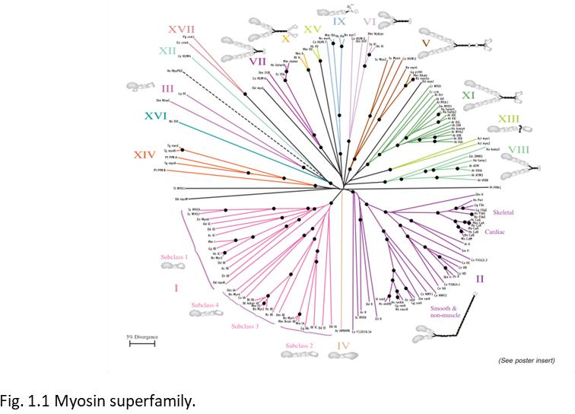

next section.

Myosin architecture

Electron microscopy studies showed that myosin is composed of two globular head domain and coiled coil domain (Figure. 1.2 adapted from Yamamoto et al., 1999). The coiled coil region allows the homodimerization of two myosin proteins allowing two globular head domains per myosin molecule. This globular domain performs the major function of force and movement generation on actin filament during ATP hydrolysis. Hence, globular head domain contains binding sites for actin and ATP named as actin binding cleft and active site respectively (Rayment et al., 1993).
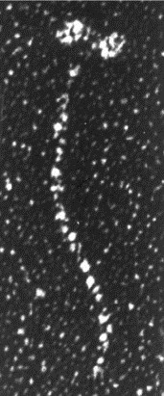
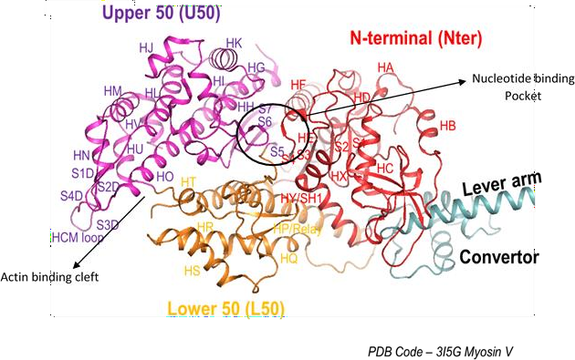

b
a
Figure 1.2 – Myosin protein structure (a) Electron microscopy image of muscle myosin showing the globular subdomain and coiled coil region. Domain organization of myosin motor domain is shown. N-terminal, U50, and L50 domains, and lever arm and converter domains are highlighted. Distinct strands and helices are labelled according to convention followed for myosin. The encircled region shows the nucleotide binding pocket containing P-loop (red from N-terminal domain), Switch I (magenta from U50 domain), and Switch II (orange from L50 domain). The actin binding cleft region
between U50 and L50 region is indicated.

Furthermore, this globular head domain has been resolved to the level of atomic details through structural studies. Head domain is composed of four subdomains, namely N-terminal, Upper-50 (U50), Lower-50 (L50) and convertor subdomain. ATP binding pocket (active site) is composed of P loop, switch (SWI) and Switch II (SWII) from N-terminal, U50 and L50 respectively. U50 and L50 domains form actin binding cleft, crucial for actin binding. The convertor subdomain goes on to form a lever arm, essential for force and movement generation on actin filament. These key regions allow myosin to function in a variety of cellular processes that are listed in next section.

Functions of myosin

Myosin functions in a variety of cellular processes like cell division, migration, vesicular trafficking, and in cell shape maintenance and in defining the position of cell organelles. Each myosin type is dedicated for specific functions like myosin II, V and X are involved in the vesicular transport, myosin XVa maintains the filopodia structure and myosin I, VI and XVa are present in stereocilia, involved in hearing process. Roles of myosin I, II and VI in transcription process are rather new to the field (Pestic- Dragovich et al., 2000; Vreugde et al., 2006).
Other than functioning independently at specific cell morphological structures or within and across cell compartments, myosin also forms a higher order acto-myosin organization to function e.g. muscle myosin II forms thick filament in sarcomere and non-muscle myosin forms the acto-myosin ring for the cytokinesis process in cell division (Figure 1.3) (Vicente-Manzanares et al., 2009). The force and movement generated on
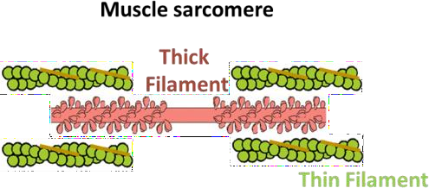
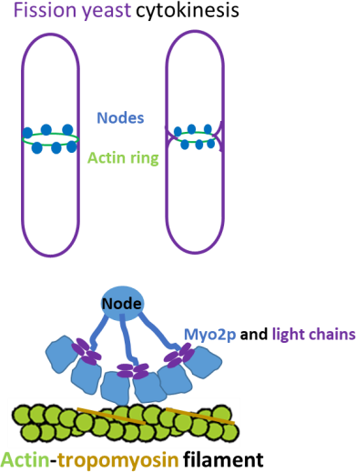
Figure 1.3 Acto-myosin cytoskeleton organization in (a) muscle sarcomere and in (b) Fission yeast cytokinesis acto-myosin ring.

actin filament by myosin heads in the overlap between thick and thin filament of muscle sarcomere causes the sliding movement actin filament resulting in muscle contraction (Huxley and Hanson, 1954; Kühne, 2011).
Similarly, cytokinesis studies through fission yeast as a model organism has shown that at the onset of mitosis, the medial cortical nodes assemble to form a cytokinesis ring. These nodes are a complex organization of cytokinesis ring proteins like tropomyosin (Cdc8), actin, Myo2p (myosin) and many others that assemble at the medial cortical
region of the cell (Pollard and Wu, 2010). Then during cytokinesis, even though other myosin types like Myp2p and Myo51 (Type V myosin) are part of cytokinesis ring, Myo2p acts as a major motor which generates force for the ring contraction leading to the cytokinesis (Zambon et al., 2017).
Even though myosin functions from very simple level of vesicular transport to the complex organization like muscle sarcomere or cytokinesis actin ring, the basic mechanical process of force and movement generation through ATP hydrolysis remains conserved and, this mechanical process is achieved through ATPase cycle which is discussed further in the next section.

Myosin ATPase cycle and conformational changes


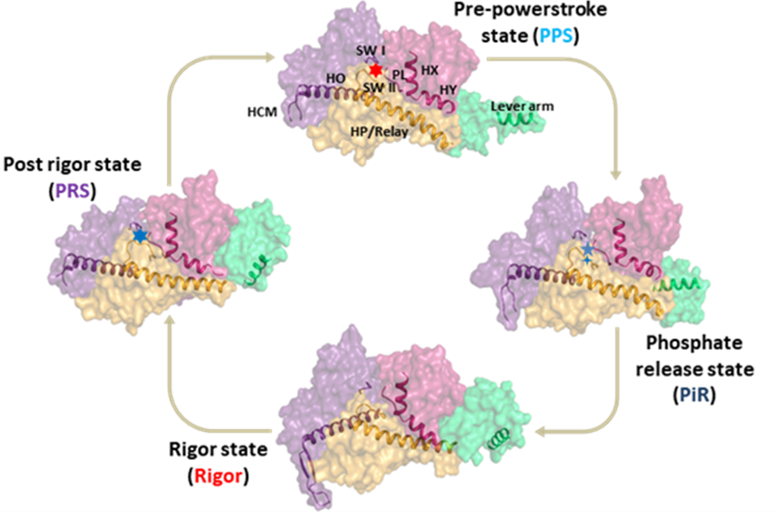
Myosin performs the ATPase activity through a four-state conformational cycle (Lymn and Taylor, 1971) (Figure 1.4). In order to study this conformational cycle, many structural studies elucidated the conformation of key regions and secondary structures attained by myosin in response to ATP hydrolysis steps.
Figure 1.4. Myosin ATPase cycle – figure shows the four steps of myosin ATPase cycle namely Pre-powerstroke state (PPS, light blue) bound to transition state ATP (six pointed star), phosphate release state (PiR, dark blue) bound to ATP hydrolysis product (five pointed blue star representing ADP, four pointed blue star aspPhosphate), nucleotide free and strongly bound to actin rigor state (Red) and the post rigor state (PRS, Purple) bound to ATP (six pointed star, blue) and unbound from the actin. Figure depicts the surface presentation of four subdomains and major secondary structure that plays crucial role in an allostery which are N-terminal (marine, HY helix and P-loop), Upper-50 (purple, HO helix and SWI), Lower 50 (orange, HP helix and SWII) and convertor (green, lever arm) domains.
Conformational
states of ATPase cycle consists of, namely Post rigor state (ATP bound: PRS), pre- power stroke state (transition step and weak actin interactions; PPS), phosphate release state (PiR, bound to hydrolysis products and weak actin interactions) and lastly in Rigor state (nucleotide free and strongly bound to actin) (Llinas et al., 2015).
The major conformational changes which lead to force and movement generation on actin filament happens during PPS to rigor state transition through a power stroke. Power stroke involves the lever arm swing (up to down transition of lever arm position), actin binding cleft closure and transducer sheet (S1B-S7B strand) twist. During this transition step, phosphate release from active site (captured in PiR state) gates the PPS to Rigor state transition (Houdusse and Sweeney, 2016). The next transition
Table 1.1 Conformation of crucial secondary structures, active site, ATP, transducer sheet during
states of ATPase cycle.

Parameter | PRS | PPS | Pi release | Pre-Rigor | Rigor
Bound ATP-γ-Pi (geometry) | Tetrahedral | Trigonal bipyramid/Tetrahedral | Tetrahedral inorganic Pi | ADP only (empty gamma PO4  position) | Nucleotide free
HP helix | Straight | bent | bent | Straight | Straight
Lever arm | Up | Up | Up | Down | Down
HY helix | Unwound | Intact | Intact | Intact | Intact
Outer cleft | Open | Open | Open | Closed | Closed
Salt bridge  between (SWI and SWII) | Broken | Present | Broken | Broken | broken
Actin affinity | No | Weak | Weak | Medium | Strong
Transducer  Sheet | Untwisted | Untwisted | Untwisted | Twisted | Twisted

of Rigor to PRS state is characterised by the recovery stroke which primes the myosin head domain for next cycle by cleft opening and lever arm movement (from down position to up).
These cyclic conformational changes in key secondary structures, transducer sheet, actin binding cleft and lever arm (summarised in Table 1.1) are coupled with the ATP

hydrolysis status at the active site. This further brought up an idea of allostery in the myosin research field (Rayment et al., 1993). The allosteric conformational changes that allow the coupled movement of active site and lever arm helix are extensively studied through structural, mutational and bioinformatics studies (Chinthalapudi et al., 2017; Geeves and Holmes, 2005; Yang et al., 2007). These studies elucidated that the angular motion of HY ad HP helix relays the signal of ATP hydrolysis status from active site to lever arm region (Yang et al., 2008). Compared to the lever arm region, the mechanistic details behind allosteric communication between active site and actin binding cleft are still unknown e.g. the field is still unaware of the secondary structures and residues that allow communication between actin binding cleft and active site during PPS to rigor transition.
Along with bringing many insights in the allostery of myosin, structural studies also gave explanation at the molecular level for myopathy diseases, a genetic disorder caused by myosin mutation. These myopathy diseases and its studies are discussed in the next section.

Myopathies and allosteric conformational change studies

Mutations in myosin cause many types of myopathies namely, hyper and dilated cardiomyopathy, neuropathy, muscle weakness, deafness and many other syndromes (Oldfors et al., 2004). About 500 mutations in myosin are reported to cause cardiomyopathies. Out of these 500 mutations, 300 mutations are located in myosin head domain (Colegrave and Peckham, 2014). These indicate that these mutations must be affecting the myosin ATPase, force and actin filament movement generation properties. Alternations in these properties were further confirmed through bio- physicochemical studies. For example, H251N and D239N cardiomyopathy mutations are known to increase the force and velocity of sliding of actin filament (Nag et al., 2017). Moreover, many structural studies also tried to give mechanistic explanation for altered properties upon mutation. This mechanistic explanation further elucidated that cardiomyopathy mutations affect the allosteric conformational changes in head domain and thereby biochemical properties also. Hence elucidation of allostery in myosin head domain can advance our understanding of effect of cardiomyopathy mutation on myosin properties.

Cardiomyopathy mutations are scattered over entire motor domain but specifically, mutations near lever arm and convertor domain region are extensively studied. These cardiomyopathy mutations lie on HY, HP helices and on convertor subdomain, suggesting a possible way of disruption of allosteric communication between active site and lever arm helix (Spudich, 2015). Because of this focused study at one region, understanding of cardiomyopathy mutations from the core region in the motor remains elusive. The way in which these mutations can affect myosin allostery and properties is still unknown.
Upon identifying the missing links in allosteric communication studies between active site and actin binding cleft and cardiomyopathy mutation studies, we came up with the rationale for the 5th year Master Thesis work.

Rationale of the study

Lever arm and actin binding cleft movements have been studied in a great detail, but still the conformational changes during power stroke (PPS to Rigor transition) has remained ambiguous. Interestingly, the central seven stranded beta sheet (S1B to S7B strands) which spans the entire motor domain also undergoes a twist during PPS to Rigor state transition which allows force generation (Coureux et al., 2003). Similar to the allosteric communication between active site and lever arm, the communication between actin binding cleft and active site is not studied thoroughly. These two sites are connected via core regions of U50 and L50 subdomains which hosts for 70% of cardiomyopathy mutations. Hence, the core of motor domain still remains mysterious about conformational changes at the residue level. This is where we came to the objective of our study.

Objectives of the project

- Identifying the residues driving the allosteric communication between nucleotide binding pocket and actin binding cleft during power stroke.
- Validating the potential residues through in vivo mutation study using fission yeast as model organism.

Approach of the study

Until now, about 113 myosin structures of different types from various organisms have been published which presented us with a large data set for a comprehensive structural analysis to understand the role of residues from core motor domain in global

allostery events in myosin. Our top to bottom approach of study from subdomain movement to the secondary structure movement allowed us to identify crucial secondary structures which move in response to nucleotide binding pocket elements thereby allowing conformational changes to get conveyed to distal parts. This subset of crucial secondary structures led us to the conserved residues and coupled contacts among them which forms residue connection pathway from nucleotide binding pocket to the actin binding region.
These residues correspond to the residues involved in cardiomyopathy disease in humans. In order to test the role of these residues experimentally, we chose cell division in fission yeast as a model system. Cell division process in fission yeast involves the acto-myosin ring contraction at the middle of the cell for two daughter cells to separate. Defective ring contraction compared to wild type upon mutation in Myo2p protein involved in ring contraction would provide us with validation for crucial nature of the residue. Moreover, tuning of residue connection pathway through temperature sensitive mutation further supported the importance of residue connection pathway. Hence, in all, through structural and in vivo mutation study we were not only able to identify the potential residues but were also able to experimentally validate them.

Chapter 2. Materials and Methods

Acquisition of structures

Myosin structures were acquired from Protein Data Bank (https://www.rcsb.org/)) source. Myosin structures on the PDB server were identified through DALI server (http://ekhidna2.biocenter.helsinki.fi/dali/) using 1VOM (PDB id) as a template to fetch similar structures from the server (Holm and Laakso, 2016). About 113 structures were acquired out of which 110 structures were involved in the analysis based on the resolution criterion. Myosin structures were divided into individual myosin types and organism wise (Table 3.1). Then, the structures of each myosin types were further divided into the ATPase cycle state in which structure was captured.

Structural parameter calculation

No. | Parameter | Residue I | Residue II
1 | Outer cleft | S416 (Cα) | K589 (Cα)
2 | Inner cleft I | R232 (Cα) | F461 (Cα)
3 | Inner cleft II | S181 (N) | F458 (O)
Calculation of the myosin structural parameters outer cleft, inner cleft I and II involved the calculation of distance between two atoms using ‘Measurement’ command from PYMOL software. The atoms used for structural parameter calculation in 1VOM
Table 2.1 Atoms chosen for calculation of structural parameters.
(ddmyoII structure) are listed in Table 2.1. Corresponding atoms from all other structures were selected for their structural parameter calculation.

RMSD heatmap calculation

Root Mean Square Deviation (RMSD) values were acquired from the alignment of C-alpha atoms from a mobile structure with the reference structure’s C-alpha atoms. ‘Align’ command was used for the alignment purpose. Based on the domain boundaries of 1VOM (ddmyoII structure) (Table 2.2), we selected corresponding Cα atoms from other myosin types’ domains. All pairwise structure RMSD calculation involved the alignment of Cα atoms of the N-terminal domain of one structure with the corresponding atoms from all other structures to obtain the RMSD values. A similar procedure was
Table 2.2 Table shows the Cα boundaries chosen for N-terminal, U50 and L50 subdomain from 1VOM ddmyoII structure.
No. | PDB code | N-terminal (Cα) | U50 (Cα) | L50 (Cα)
1 | 1VOM | 1-199,649-691 | 209-454,592-612 | 455-591,630-648

carried out for the other two subdomains (U50 and L50) also. Microsoft excel software was used to generate the heatmap out of pairwise RMSD values.

Secondary structure movement calculation

Before movement calculation for secondary structures, all ddmyoII and ssmyoVI secondary structures were brought to the reference point by the alignment of L50 domain with reference structures 1VOM (ddmyoII) and 4DBR (ssmyoVI) respectively. Then, individual secondary structures selected based on the Cα boundaries of 1VOM (ddmyoII structure) from all other structures. Then, C-alpha atoms were aligned with the corresponding secondary structures from respective reference structure. This

alignment provided us with alignment matrix which was further used to calculate the spherical polar angles.

Table 2.3 Table shows the Cα boundaries chosen for secondary structures from N-terminal, U50 and HP helix from L50 subdomain for 1VOM ddmyoII structure.
No. | Secondary structure | Cα atom boundaries
1 | HC | 99-112
2 | HD | 137-143
3 | HE | 155-170
4 | HF | 187-199
5 | HX | 663-676
6 | HY | 676-688
7 | S1B | 115-120
8 | S2B | 122-128
9 | S3B | 644-652
10 | S4B | 174-179
11 | HG | 204-212
12 | HH | 212-219
13 | HI | 272-281
14 | HJ | 284-291
15 | HK | 313-329
16 | HL | 332-347
17 | HM | 366-377
18 | HN | 380-389
19 | HO | 405-435
20 | HU | 589-598
21 | HV | 601-607
22 | S5B | 442-448
23 | S6B | 234-242
24 | S7B | 247-256
25 | S1D | 351-365
26 | S2D | 359-363
27 | S3D | 340-395
28 | S4D | 398-403

Secondary structure spatial proximity heatmap calculation

Spatial proximity among secondary structures was determined using pairwise minimum Cα atom distance between secondary structures. These pairwise Cα atom distances were used to generate the heatmap in Microsoft excel sheet.

Sequence Conservation analysis

For the residue conservation analysis, we fetched 237 non-redundant myosin sequences from Uniprot server (https://www.uniprot.org/) using blast search (Bateman et al., 2017). These sequences were uploaded on Consurf server (http://consurf.tau.ac.il) to obtain the residue conservation score for every residue position in motor domain (Ashkenazy et al., 2016).

Strategy for creating myosin mutation strains

As Myo2p is an essential gene in fission yeast, to make a myosin mutation strain we had to use a special strategy. To make the strain we started with Myo2p diploid strain having one copy of Myo2p deleted with Ura gene fragment (Uracil synthatase). The strain was maintained in diploid status by ade6-210/ade6-216 genotype hence, cells having both of this alleles can survive on the adenine deficient medium. The vector used for integration of Myo2p wild type and mutation constructs allows the integration at leu- locus making the strain leu+ (can survive on leucine minus plate).
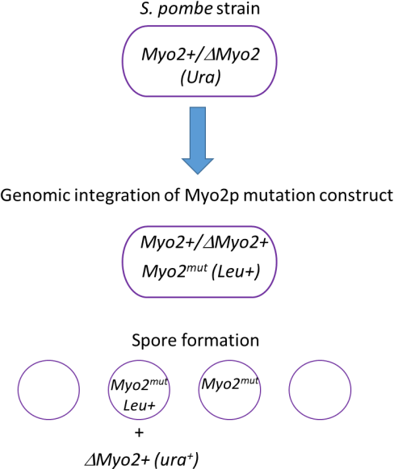
Figure 2.1 Figure depicts the strategy used to obtain the Myo2p null and Myo2p mutation constructs.

Upon integration, diploid strain was allowed to form spore on ELN (Extremely low nitrogen) plate. The formed spores were segregated using tetrad dissection method and were further selected for the Leu and Ura marker. The cells that grow on uracil and leucine deficient medium, will confirm that cells have Myo2p deleted copy and the integrated copy of our Myo2p wild type and mutation constructs.

Cloning for myosin mutation constructs

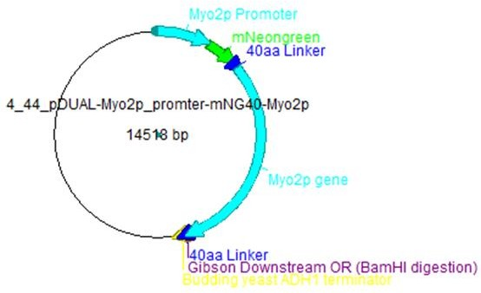

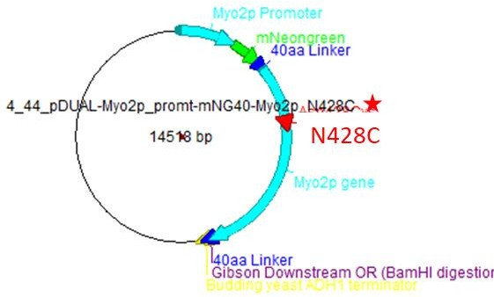
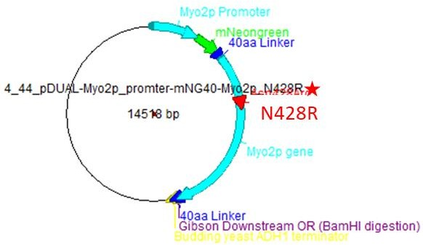
For the integration purpose of Myo2p wild, Asn428Arg and Asn28Cys mutation constructs were cloned into pDUAL vector for integration into Leu locus. To maintain the expression level of integrated Myo2p construct equal to native Myo2p expression level we used a Myo2p promotor for the integration constructs. So, we swapped the padh11 promoter from the pDUAL vector with Myo2p promoter (1183 bps upstream of Myo2p coding region). We retained mNeon Green (fluorescent Marker) from pDUAL vector for the Myo2p imaging studies. We amplified Myo2p promoter using fission yeast genomic DNA and was further integrated in pDUAL vector by Gibson assembly method (Figure 2.2).
a
c
b

Figure 2.2 Figure depicts vector map of pDUA Lintegration vectors for Myo2p wild type (a), Myo2p
N428R construct (b) and Myo2p N428C construct (c).
c

After the integration of Myo2p promoter into pDUAL vector, we integrated the Myo2p Wild and mutation constructs into vector by Gibson assembly method after mNeon Green. Myo2p mutation constructs were amplified from Myo2p genomic DNA by two PCR method and were integrated into pDUAL vector by Gibson assembly method. To amplify the DNA fragments by PCR method following protocol was used:
PCR protocol:-

DNA Template - 1 μl ~ 100 ng
Forward and Reverse Primer – 1 μl (20 μM) each Deoxy-Nucleotide Triphosphates – 1 μl (40 mM)
DNA Polymerase Buffer – 10 μl (HF Phusion polymerase buffer 5X) DNA polymerase – 0.5 μl (HF Phusion polymerase)
Water – Volume making upto 50 μl

For the Gibson assembly following protocol was used:-

Gibson assembly mix – 0.5 μl (Sigma Gibson assembly mixture 2X) DNA insert – 1 μl (300 ng)
Cut vector – 0.5 μl (100 ng)

This mixture was incubated at 50 degree for 1 hour and then was used to transform the DH5α cells to obtain the clone. Further, integration of wild type and mutant constructs were confirmed by DNA sequencing.

No. | Primer Name | Primer Sequence
1 | Myo2p Asn428Arg Fw | CTGGTAAAGCGACTTcgtACTTCCTTGAACCAT
2 | Myo2p Asn428Arg Rv | ATGGTTCAAGGAAGTacgAAGTCGCTTTACCAG
3 | Myo2p Asn428Cys Fw | CTGGTAAAGCGACTTtgtACTTCCTTGAACCAT
4 | Myo2p Asn428Cys Rv | ATGGTTCAAGGAAGTacaAAGTCGCTTTACCAG
5 | Myo2p Promoter integration Fw primer | CCAAGCTTGCATGGCATGCATTTCCCTACC
6 | Myo2p Promoter  integration Rv primer | CCATCCAGGCCTGTCGACGGGCTACTCTCT
7 | Myo2p gene Integration Fw | GGCCCCGGTCAGGGAATGACAGAAGTAATA
8 | Myo2p gene Integration  Rv | TAGAAGTGGCGCGCCGGATCCTCATGCGGCGCG  CAAC
No. | Strain | Genotype of Strain
1 | MBY340 | h90/h90, ade6-210/ade6-216, leu1/leu1, ura4- D18/ura4-D18, ura⁺/Myo2p⁺

Table 2.4. Table for primers and strains used in the study.

Yeast transformation

Yeast diploid strain (MBY340) cells were inoculated in 10 mL EMMA (Adenine and Uracil deficient) culture. Next day morning, dilute the cells to 0.2 OD600 in 20 mL culture and keep at 24 degree temperature incubator until 0.5 OD600. Then, spin down the cells

at 3400 rpm for 5 minutes. Then, wash cells with sterile water. After the wash, rewash the cells with 1 mL of TE/LiAc 7.5 pH buffer and then resuspend in 100 μl of TE/LiAc
7.5 pH buffer.Add 2 μl of Hering sperm DNA and 10 μl of DNA fragment of interest (Myo2p wild type and mutations constructs) to the cells. Keep the cells at room temperature for 20 minutes with shaking. Meanwhile, make mixture of 800 μl of PEG 50% (freshly made), 100 μl of TE buffer and 100 μl of 1 M LiAc solution. After 20 minutes, add 240 μl of PEG 50%/TE/LiAc solution to the mixture and further incubate at 24 degree for 1 hour along with shaking. Add 43 μl of DMSO. After this, heatshock the mixture at 42 degree for 5 minutes. Then, wash the cells with 1 mL of sterile water and resuspend into 100 μl of sterile water for spreading on the selection plate. After 3- 4 days, the yeast transformant colonies would appear on plate. Confirm the integration of DNA fragment of interest by PCR amplification and sequencing.

Extraction of yeast genomic DNA

Pin head of yeast cells were taken to which 100 μl of DNA extraction buffer (0.2 M LiAc + 1% SDS) was added. Then, the mixture was kept at 70 degree for 5 minutes incubation. 300 μl of 100% ethanol was added to the mixture. Mixture was spun down at 13000 rpm for 3 minutes. Supernatant was removed and was washed with 70% ethanol twice. Pellet was air dried and then the pellet was further resuspended into 100 μl of sterile water which was used for DNA amplification from yeast genomic DNA.

Ring Isolation

Yeast strain was inoculated in 20 mL YEA (growth media) media, 200 rpm, 24 degree temperature. Next day morning, cells were sun down at 3400 rpm for 3 minutes and was resuspended in 30 mL 0.5% low glucose minimal media and was kept at 24 degree, 200 rpm incubator. In the evening, culture was diluted to OD600 ~ 0.04 in 80 mL of 0.5% low glucose minimal media. Next day morning, 50 mL culture was spun down at (0.5 OD600) at 3400 rpm, 24 degree for 3 minutes. Cells were washed with 10-20 mL of 1x E-buffer (50 mM Sodium citrate, 100 mM sodium phosphate). Cells were resuspended in E-buffer (1.2 M sorbitol) in 10 mL containing 0.025 g lysing enzyme. Incubated the resuspended cells at 24 degree, 80 rpm for 1 hour 20 minutes. 20 μl of zymolyase enzyme was added and was further incubated for 1 hour at 24 degree, 80 rpm. At this stage, yeast cells form protoplast, cells lacking cell wall. Formed protoplast was spun down at 450x g for 2 minutes and was washed with 10 mL of E-buffer (0.6 M sorbitol) (Add gently from the sides of falcon tube).

Then, the protoplast was incubated in 10 mL culturing medium (minimal media (2% glucose EMMA) + 0.8 M sorbitol + supplements), 80 rpm, and 24 degree for 3.5-4 hours. Again protoplast was spun down at 450x g for 2 minutes at room temperature (supernatant was gently removed). The protoplast was gently mixed with 1 mL of Wash buffer (4 degree) and then the protoplast was transferred to the chilled 2 mL eppendorf tube and was spun down at 450x g at 4 degree for 2 minutes. 1.5 mL isolation buffer was added and gently mixed. Homogenized the protoplast using chilled glass homogeniser (homogenize 6 times on ice and avoid bubble formation) and was kept on ice for 5 minutes. Homogenised sample was spun down at 450x g, 4 degree for 2 minutes. Supernatant was discarded using pipette. Pellet was washed twice with 1 mL of Reactivation buffer at 450x g, 4 degree for 2 minutes and was resuspended the cells in 100 μl of Reactivation buffer.

Buffer compositions

- Wash Buffer (4°C Storage)

0.8 M sorbitol, 2 mM EGTA, 5 mM MgCl2, and 20 mM PIPES–NaOH (pH 7.0)

- Isolation Buffer (4°C Storage), (pH 7.05 in the absence of NP-40)

0.16 M sucrose, 50 mM EGTA, 5 mM MgCl2, 50 mM potassium acetate, 50 mM PIPES–NaOH (pH 7.0), 0.5% NP-40 (Nonidet P40 substitute, from Fluka), 10 μg /ml leupeptin, 10 μg /ml aprotinin, 10 μg /ml pepstatin, 1 mM phenylmethylsulfonyl fluoride (PMSF, in the NCB paper, 0.5 mM was used) and 1 mM dithiothreitol (DTT)

- Reactivation Buffer (4°C Storage), (adjusted to pH 7.5 with NaOH)

0.16 M sucrose, 5 mM MgCl2, 50 mM potassium acetate, 20 mM MOPS–NaOH (pH 7.0), 10 μg /ml leupeptin, 10 μg /ml aprotinin, 10 μg /ml pepstatin, 1 mM phenylmethylsulfonyl fluoride (PMSF) and 1 mM dithiothreitol (DTT)

- 0.05% low-glucose minimal media and supplements

Tale EMMA 2X (in 500 ml bottle). Make up to 1L using: 10 ml of 50% glucose
20 ml of 50X salt

1ml of 1000x vitamins and supplements (found in 4°C)

2 bottles of supplements for each amino acid (leucine, adenine, histidine, lysine and uracil).

Make up to 1L using sterile H20. Mix and filter sterilize.

2.13 Confocal Microscopy imaging studies

Time lapse movies for Myo2p and mutant constructs were acquired from spinning disk microscope (Andor Revolution XD imaging system) at 25 and 36 degree. Imaging was acquired by cells grown in YEA media at 25 degree to the 0.4 OD600 by YEA agarose pad method. Myo2p mNeon Green served as a marker for cytokinesis actin ring which was imaged at 488 nm wavelength by 300 ms exposure and 12.3% intensity. Fiji software was used to visualize the time lapse images. Manual tracking was used to calculate the ring contraction rate.

Chapter 3 – Results

The chapter describes the results obtained from the structural analysis, followed by the experimental validation of the potential residues in myosin allostery using fission yeast cell division as a model system.

Dataset of myosin structures

We acquired 113 myosin structures of different myosin types from various organism (Methods 2.1). Each myosin structure was assigned a state from ATPase as per stated in its respective paper. Out of 113, 110 structures were chosen for structural analysis based on resolution criterion of 4 Angstrom (Table 3.1). For the cryo-electron microscopy

No. | Myosin | Organism | No. of  Structures
1 | Myosin I | A. irradians | 11
 |  | H. sapiens | 1
 |  | M. musculus | 1
2 | Myosin II | D. discoidium | 43
 |  | G. gallus | 4
 |  | P. magellanicus | 3
 |  | H. sapiens | 2
 |  | D. melanogaster | 1
3 | Myosin V | G. gallus | 4
 |  | H. sapiens | 2
 |  | T. pacificus | 3
 |  | M. musculus | 1
4 | Myosin VI | S. scrofa | 23
5 | Myosin VII | B. tauras | 2
 |  | H. sapiens | 3
6 | Myosin X | H. sapiens | 3
7 | Myosin XI | G. gallus | 3
structures, we chose 5.5 Angstrom as a resolution criterion.
Table 3.1. Table of number of structures of various myosin types from different organism.

Upon acquiring all myosin structures we went ahead with our next analysis.

Analysis of myosin structural parameter studies

The quantification of distances and angle parameters in allostery sites such as nucleotide binding pocket and actin binding region allowed us to estimate the conformational changes in various structural states across 110 crystal structures available in the PDB (Table 3.1). The three parameters chosen for our analysis were two distance measurements near nucleotide binding pocket termed as inner cleft


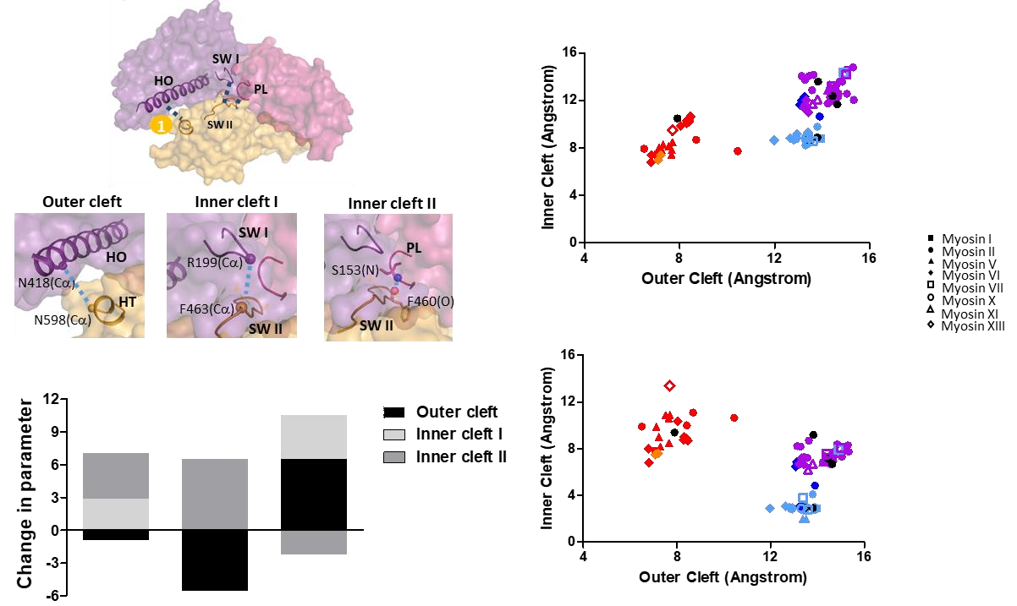

a
b
c
d
Figure 3.1 – Structural parameter studies on myosin structures (a) Figure depicts the location, secondary structures and atoms which were chosen for the calculation of structural parameters in myosin motor domain. N418Cα (HO) and N598Cα atoms shown with solid spheres were used to calculate outer cleft, R199Cα and F463α atoms were chosen for inner cleft II and S153(N) and F460(O) were chosen for inner cleft II distance measurement. (b) Figure depicts the scatter plot between inner cleft I and outer cleft where each points depicts a myosin types shown adjacently. The color of points indicates the conformational state of the structure Blue for PPS, Magenta for PRS, Red for Rigor, Dark blue for PiR and Orange for ADP bound state. (c) Figure depicts the scatter plot between inner cleft II and outer cleft. (d) Figure depicts the change in outer cleft (black bar), inner cleft II (grey bar) and inner cleft I (light grey bar) during PRS to PPS, PPS to Rigor and Rigor
to PRS respectively.

distance I and II, and the outer cleft distance near the actin-binding region (Figure 3.1) (Yang et al., 2007).

Inner cleft I is the distance between the closest Cα atoms of switch II (SW II) and switch I (SW I) of the ATP binding pocket, while inner cleft II represents the corresponding distance between SW II and P loop (Figure 3.1b). The outer cleft distance depicts the distance between Cα atoms of N498 (U50) and N598 (L50) residues (numbering according to ddMyoII), located at the tip of U50 and L50 subdomains near actin binding cleft (Figure 3.1a).
In order to elucidate the coupling between structural parameters, a scatter plot was generated which grouped all myosin structures into three major clusters representing PPS, PRS and Rigor states of the ATPase cycle (Figure 3.1b and 3.1c). Other states like PiR and ADP bound states (a state having bound ADP and actin) were observed within the PRS and Rigor states respectively. Furthermore, the structures that were not assigned to any state in published literature (represented in black) also lay within these clusters, thus enabling us to assign a conformational state to these structures also.
In the scatter plot, comparison of Rigor with PPS or PRS states demonstrated a characteristic increase in outer cleft distance, consistent with the decrease in actin binding affinity as myosin adopts the PPS or PRS state conformation. During Rigor to PRS transition, there is also an increase in inner cleft I distance while the inner cleft II distance remains the same. An increase in inner cleft II distance during PPS to Rigor transition, with the inner cleft I distance being maintained the same. Interestingly, these features remained constant, irrespective of the myosin sub-types or the organism. Furthermore, a decrease in the outer cleft distance during PPS to Rigor transition is accompanied by an increase in inner cleft II distance only, which implies that the P-loop (part of N-terminal domain) moves during this transition step (Figure 3.1d). This may be correlated with the tensed conformation of the transducer sheet in the N-terminal domain. Hence, intriguingly, PPS to Rigor state transition appears to be a step where the cleft closure is not driven by a direct influence on the L50 and U50 domains, but may be by an allosteric effect involving the N-terminal domain. The transition from Rigor to PRS involved an increase in the inner cleft distance, implying a movement of the SW I, which is part of U50. This could have a direct effect on the movement of the U50 domain for cleft opening.
As of now, we established the correlation between movement of specific nucleotide binding motifs and cleft closure but further to understand mechanistic details behind

these correlations we used a subdomain wise superposition approach which could track the movements within subdomains in response to the nucleotide binding loop movements.

Analysis of intra-domain motion across conformational states of myosin motor domains
To facilitate the comparison, we represented the subdomain-wise conformational variability among the 110 myosin structures in the form of a heatmap of pairwise RMSDs (Figure 3.2, Method 2.3). In the heatmap, green color denotes conformational states that are distinct, while red denotes similar conformations. Similar to the structural parameter plot, RMSD heatmap also classified the structures into their appropriate conformational states. Any conformational state that is an outlier was observed as a row (or a column) that had a variation in the color within the boundary of similar conformational states. One of the striking observations was the structures of PDB IDs 2Y8I, 2Y9E and 2Y0R (Figure 3.2, a position highlighted in heatmaps with green pointers) whose structures were drastically distinct in conformation compared to PRS ddmyoII structures (Preller et al., 2011). Perhaps, the dissimilar conformation of these three structures is due to the G680 mutation in the N-terminal domain which drastically affects the N-terminal domain conformation compared to the other two domains. Interestingly, even though mutation belongs to the N-terminal subdomain, the mutation appears to contribute to conformational variability of all the subdomains, as it can be observed from the heatmaps.

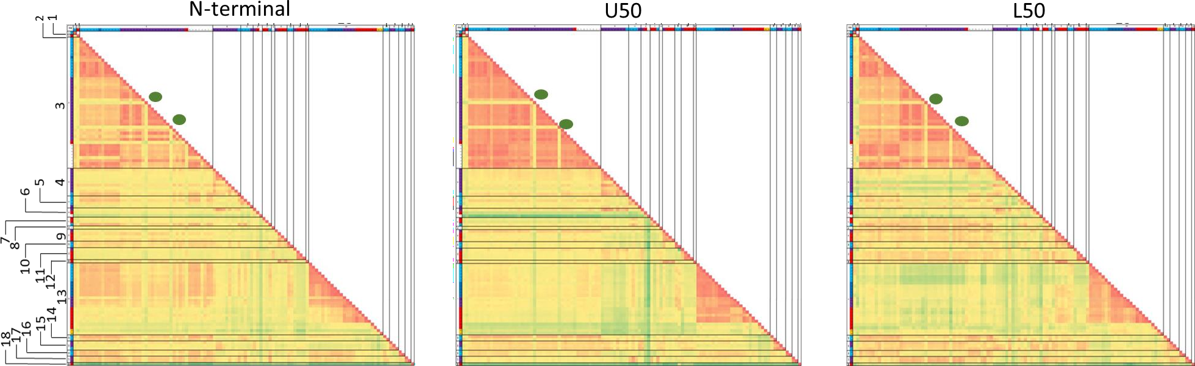

A
A
A
29

0
2.5
0
1.7

Figure 3.2. All structure domain-wise RMSD heatmap – Heatmap for pairwise-subdomain alignment RMSD values for N-terminal, Upper-50 (U50)
and Lower-50 (L50) domains for available myosin structure. Each number on the heatmap represents the myosin type from specific organism. Myosin I
– 1 (H. sapiens), 2 (M. musculus) Myosin II – 3 (D. discoidium), 4 (A. irradians), 5 (G. gallus), 6 (P. magellanicus), 7 (H. sapiens), 8 (D. melanogaster). Myosin V – 9 (G. gallus), 10 (H. sapiens), 11 (Squid), 12 (M. musculus). Myosin VI – 13 (S. scrofa). Myosin VII – 14 (B. tauras), 15 (H. sapiens). Myosin X – 16 (H. sapiens). Myosin XI – 17 (G. gallus). Myosin XIII – 18 (Rabbit). Color scale for each subdomain heatmap shows the least (red) and highest
(green color) with respective value.

The heatmap showed distinct zones of high (green) or low (red color) RMSD values. Among ddmyoII conformational states, zone A highlights that the PRS state domain conformation is different from that of PPS state, especially for the N-terminal domain. Also, similar conformations were observed for the N-terminal domain of PPS states across ddmyoII (3), ssmyoVI (13), btmyoVII (14) and hsmyoX (16) structures based on red color patches.






1.5
RMSD Value (Angstrom)

1.2

0.9

0.6

0.3

0.0
dd-Nter dd-U50 dd-L50 ss-Nter ss-U50 ss-L50


Figure 3.3 Scatter plot of ddmyoII and ssmyoVI RMSD values – Scatter plot shows the distribution of RMSD values for D. discoidium myosin II (ddmyoII) structure’s N-terminal (dd-N ter), U50 (dd-U50) and L50 (dd-L50) subdomain and also for S. scrofa myosin VI (ssmyoVI) structure’s N-terminal (ss-N ter), U50 (ss-U50) and L50 (ss-L50) subdomains. Color of each point depicts the state from which it belongs like blue for PPS, Magenta for PRS, Dark blue for PiR, Orange for ADP and actin bound state and Red for Rigor state. The hollow square and circle point for ssmyoVI RMSD distribution depicts that they are cryo-EM structures.
In order to focus on conformational changes during the interstate transition of the ATPase cycle, we studied ddmyoII (3) and ssmyoVI (13) structures. These two sets have the maximum number of structures captured in each state of the ATPase cycle. A scatter plot of the RMSD values (Figure 3.3) showed us that the intra-domain conformational variation during the transition from PPS to Rigor state is highest for N-terminal subdomain compared to the U50 and L50 subdomains. Similar to the ddmyoII RMSD scatter plot, PPS to rigor transition is characterized by higher conformational changes compared to other interstate transitions. In the case of ssmyoVI RMSD scatter plot, the clusters of cryo-EM structures stood out specifically for U50 and L50 subdomains compared to N-terminal subdomain, thereby indicating that they have distinct conformation than other rigor state X-ray crystal
structures. Moreover, it implied that the true rigor state conformation of U50 and L50 domains is captured only in the actin bound form, while the crystal structures showed the near-rigor state conformation in the absence of actin.
Such variability in the subdomain conformation during ATPase cycle arises because of the movement of constituent secondary structures in response to the small conformational changes in the active site. In order to zoom in from subdomain level movements to the secondary structure movement, we used the principles of superposition in the movement calculation of secondary structures in further analysis.

Coordinated secondary structure movements during conformational transitions in the myosin motor domain
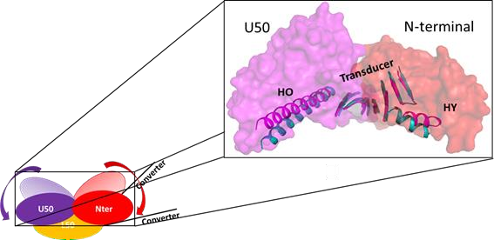
For quantifying the relative secondary structure movements during conformational changes, the spherical polar angles Ω, ϕ and κ angle were estimated from the superposition matrix obtained upon comparing the same secondary structure element from two conformational states (Methods 2.4) (Evans, 2001). We focused on the comparison between PPS and Rigor states of ddmyoII and ssmyoVI to elucidate the secondary structure movements which facilitate the actin binding by cleft closure. Alignment of L50 subdomain allowed us to visualise the trajectory of movement of secondary structures during PPS and rigor state transition (Figure. 3.4).


Figure 3.4. Trajectory of movement of secondary structures during PPS to Rigor state transition – Figure shows the animated depiction of PPS and Rigor state L50 subdomain aligned structures where movements of U50 (purple domain and arrow) and N-terminal (Red subdomain and arrow) are shown for PPS to Rigor state transition. The actual movement of selected secondary structures during PPS (Magenta color) and Rigor state (Cyan color) is shown in N-terminal (Salmon red) and U50 (Magenta). The selected secondary structures are HO, HY and transducer sheet.

κ angle specified the magnitude of angular movement while Ω and ϕ defined an axis along which κ angle is measured. Hence, κ gives the actual estimate of secondary structure movement. A plot of the κ angles for secondary structures from N-terminal and U50 subdomains showed that N-terminal subdomain’s secondary structures performed a differential amount of movement thereby indicating a plastic deformation type of conformational changes in N-terminal subdomain. In contrast, U50 domain mainly underwent a concerted movement of secondary structures.
Based on the amount of movement of secondary structures, we could reduce the entire N-terminal subdomain into hubs of secondary structures that shift together as a rigid body (Figure 3.5) e.g. HC-HD-S1-S2 (Black square), HX-S3-S4 (Green square), HE-HF (Grey square) secondary structure hubs. HY helix is not a part of any hub because its movement is larger than any other secondary structure as it correlates with lever arm swing during PPS to Rigor state

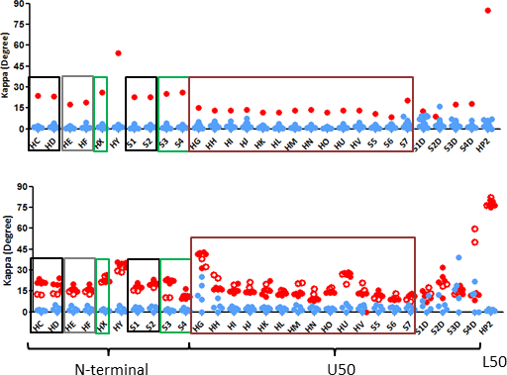
ddmyoII secondary structures
ssmyoVI secondary structures


Figure 3.5. Secondary structure movements of ddmyoII and ssmyoVI secondary structures – Figure depicts the scatter plot for ddmyoII secondary structures for PPS (Blue) and Rigor (Crystal structure) state (Red) structures. Similarly, it also depicts Kappa angle scatter plot for ssmyoVI PPS
(Blue), Rigor (Red) and Cryo-EM Rigor state (hollow red) secondary structures.
transition.

Interestingly, the conclusion regarding the concerted movement of U50 secondary structures is consistent with the low RMSD for intra-domain superposition of U50

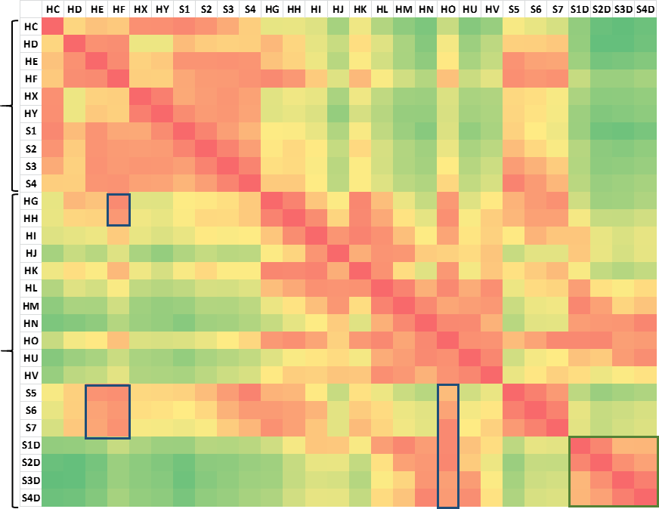


domain (Figure 3.2). The similar inferences were also drawn for ssmyoVI scatter plot but with some exceptions. For example, HY movements in ssmyoVI compared to that in ddmyoII structures which could indicate signal of myosin type specific conformational change differences. HG, HU, S1D, S2D, S3D and S4D in U50 underwent exaggerated movements due to their presence on the protein surface.
1
2
3
4
U50
N-terminal



0
61
Figure 3.6. Heatmap for spatial proximity between secondary structures– Figure depicts the heatmap for ddmyoII (1VOM) secondary structure proximity for N-terminal and U50 subdomain secondary structures. The blue square 1 and 2 represents the close proximity between N-terminal (HE/HF) and U50 (S6B/S7B) subdomains. The square 3 and 4 shows how HO helix (U50) connects S6B/S7B strand with actin binding secondary structures, S1D/S2D/S3D/S4D strand.The scale shown below indicates the maximum and minimum value for the proximity between secondary
structures. Unit of the scale is Angstrom.
Next, we proceeded to check whether the secondary structure hubs were in spatial proximity by a secondary structure contact map representation. We also looked at secondary structures at inter-domain boundaries. Interface among HF-HE (N- terminal), HG-HH (U50) and S6B-S7B connecting loop (U50) showed possible routes

which could convey the movements between N-terminal and U50 sub-domains (Figure
3.6 Blue box 1 and 2).

Until now, we came from subdomain level conformational changes shown through structural parameter analysis to the level of secondary structure movements and interfaces among subdomains. But still it is yet not clear that how secondary structure movements and subdomain interfaces are giving rise to the subdomain level conformational changes like change in the outer cleft distance. In order to connect conformational changes with the secondary structure movements, we went ahead with analysing specific residue contacts.

Connectivity of residues between secondary structures that drive allosteric conformational changes
Considering P-loop as the starting point, we proceeded to look at the inter-residue contact connecting nucleotide-binding to actin cleft movements. Disruption of the interaction between SW II and P-loop (Figure 3.7a) is accompanied by changes in the position of S4B, S3B and HX, the adjunct secondary structures which are part of the same hub (Figure 3.7b and 3.7c). The sustained contact maintained between Thr117 (S4B) and Arg654 (S3B), which in turn is in connection with Asn679 (HX) plays a crucial role to allow changes in position of their respective secondary structure during PPS to Rigor state transition. Secondary structures from other hubs in the N-terminal domain, also accompanies the change in their position with respect to the S4B strand (Figure 3.7d, 3.7e and 3.7f). HC-HD-S1-S2 secondary structure hub is connected to S4B-S3B-HX hub via Arg677 (HX) and Glu99 (HC) sustained interaction. Furthermore, the last secondary structure hub of HE and HF helix is also connected to the HC-HD-S1-S2 secondary structure hub through Gly145 (loop region) and Asp160 (HE helix) contact.
HE-HF helices are present at the boundary of N-terminal and U50 subdomain, their sustained contact with the S6B-S7B connecting loop via Tyr163 and Gly251 contact allows a change in the position of S6B-S7B strands (Figure 7g). Rigid body organization of U50 domain determined from previous analysis further suggested that all other secondary structures in U50 subdomain may accompany the change in the position of S6B-S7B connecting loop position. Thereby, we were also able to track the changes

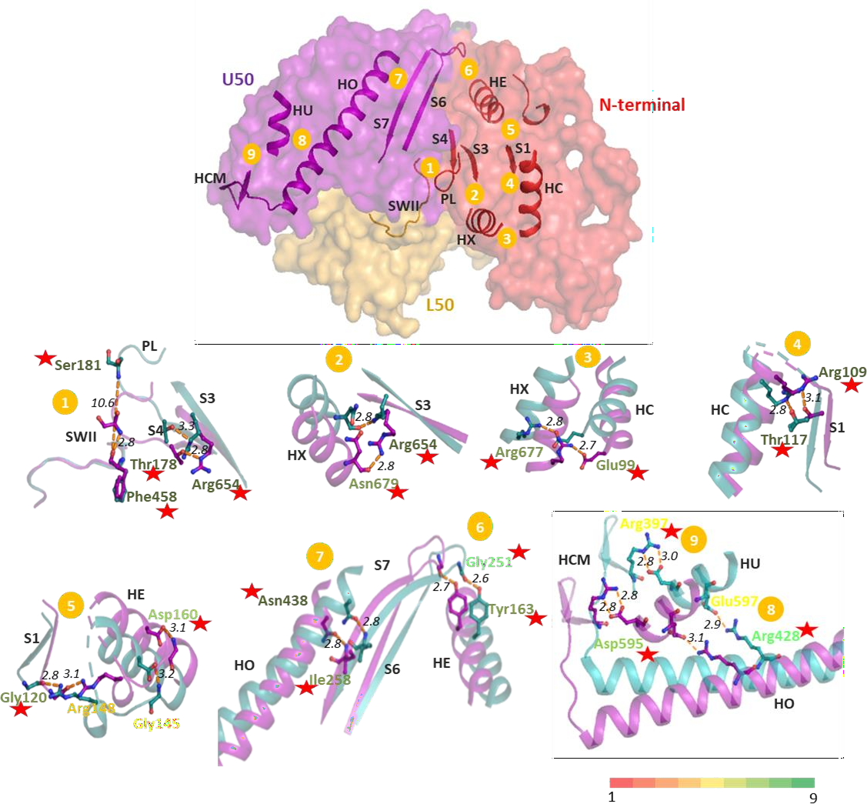
in the position of secondary structures that are in contact with S7B strand. Upon change in the S7B strand position, interaction with HO helix through Ile258 (HO) and Asn438 (S7B) allows angular motion of HO helix. HO helix’s angular motion further allows the change in position of S4D-S3D strands, the major actin binding secondary structures (Figure 3.7h).
a
b
c
d
e
g
h
f


Figure 3.7 Allosteric residue connection pathway. (a) figure depicts the secondary structures from N-terminal (red) and U50 (Magenta) subdomain involved in communication between Active site (PL-P loop and SW II) and Actin binding region (HCM loop). Each number (from 1 to 9) represents residue connection between adjacent secondary structures. Further figures from b-h shows the secondary structure conformation from PPS (1VOM, Purple) and Rigor (2AKA, Cyan) structure upon alignment of L50 subdomain (orange). (b) Figure shows the residue interaction between SW II and P loop (PL) and S4B and S3B strand in PPS and Rigor state conformation. Similarly, figures from c- h figures show interaction between depicted secondary structures in two conformations, PPS and Rigor. Each number in orange box is a guide for the location of respective secondary structure in myosin motor domain in fig 7a. Each residue interacting from two secondary structures is colored according to conservation score from 1 to 9 scale. Red stars present near the residue label highlight
it being HCM mutation in humans.

Such correlated changes in the position of secondary structures starting from hubs of the N-terminal subdomain to the U50 subdomain secondary structures allowed us to identify the residue connection chain. This chain spanned across two subdomains started from active site to the actin binding secondary structures (Figure 3.7a). Most of the residues of this connection pathway are highly conserved across all reported myosin type structures and are known to cause the cardiomyopathies in humans (Figure 7b-h). The key highlight of the residue pathway is the presence of sustained contact among residue for myosin to function during the ATPase cycle which might get broken upon mutation and thereby may affect the residue connection pathway.
To validate the importance of residue connection pathway, we first went ahead with in vivo mutation studies in fission yeast. Role of fission yeast myosins, specifically of Myo2p is very well established in acto-myosin ring contraction in the cytokinesis process. Hence, a mutation in Myo2p could affect the cytokinesis process. This may act as a proxy to validate the importance of residue.

N428 mutation design

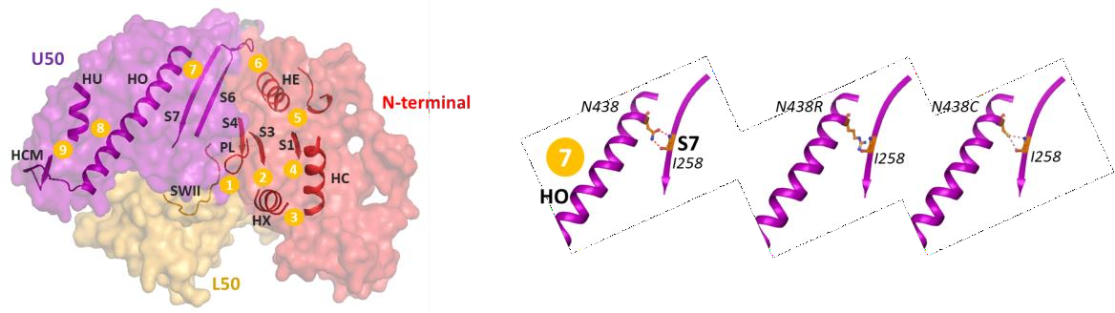

N438 residue (ddmyoII numbering) was selected from the residue connection pathway for the mutation study. N438 is a known HCM mutation from the residue connection pathway still we selected it because even though mutation in this residue show a cardiomyopathy phenotype in humans but it need not show a phenotype in fission yeast. Hence, we first went ahead with the known HCM residue which may show phenotype.
Figure 3.8 N438 residue position - Residue connection pathway on myosin structure. Selection of the residue N438 present at location 7 for mutation study is shown in whole myosin motor domain structure. Altered status of the contact in N438R and N438C mutation is also depicted.

Asn438 mutation to serine is known HCM mutation but we thought that rather than mutation to Serine, it is the breakage of connection pathway through mutation is important. So we chose Asn438Arg (ddmyoII numbering) mutation which could break the interaction through steric hindrance thereby may strongly affect myosin function (Figure 3.8). Introduction of steric hindrance may even abolish the activity of the myosin, hence to get weak effect upon N438 mutation, we mutated N438 to cysteine which changes strong ionic interaction between N438 and I258 to Van der Waals interactions thereby, giving us a weak effect.
For the mutation study, we chose fission yeast a model organism and used Myo2p protein for the mutation study. Myo2p is a major acto-myosin ring contraction motor in fission yeast hence a mutation in it may give us cytokinesis phenotype.

Cloning and Yeast transformation

Residue N438 corresponds to the N428 in Myo2p protein in fission yeast. Upon successful cloning of Myo2p Wild type, Asn428Arg and Asn428Cys constructs into pDUAL vector which facilitates integration at the leu locus, yeast strains for Myo2p constructs were obtained by LiAc yeast transformation method (Figure 3.9).
Upon integration at leu locus, Myo2p deletion was also confirmed by amplification of Ura region inserted into Myo2p native locus (Figure 11g). At each step of cloning and yeast transformation, Myo2p wild type and mutant constructs were confirmed by DNA sequencing and then, yeast clones were used for time lapse microscopy studies.

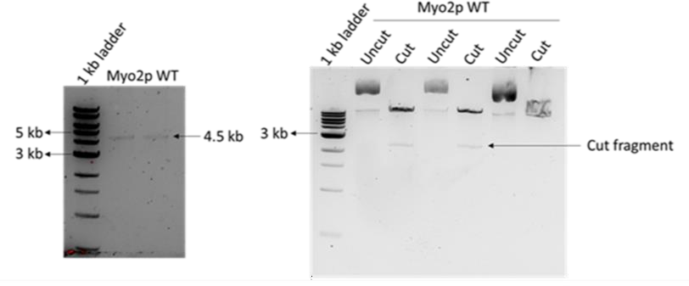
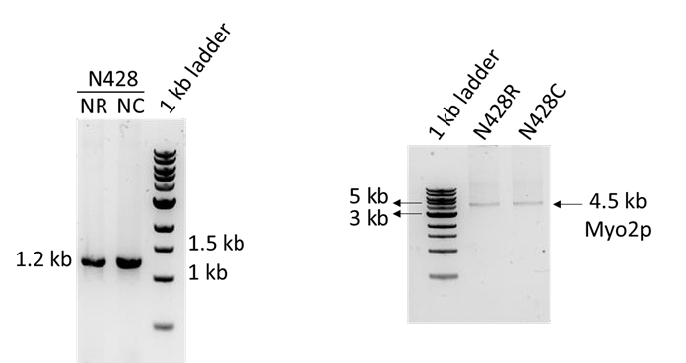
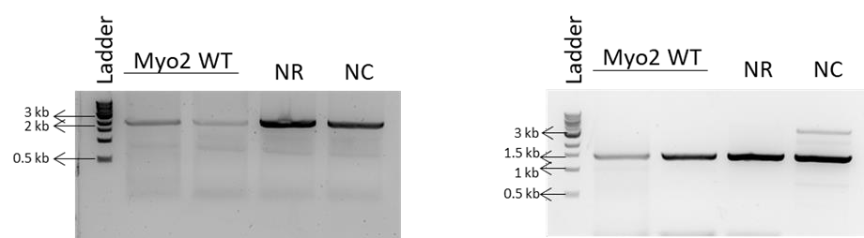
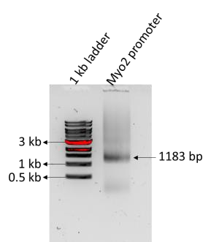
a
b
c
d
e
h
g

Figure 3.9 – Cloning of Myo2p wild type and mutation constructs – (a) Amplification of Myo2p promoter from yeast genomic DNA. (b) Amplification of Myo2p gene from yeast genomic DNA. (c) Restriction digestion clone check gel for Myo2p cloned into pDUAL vector having Myo2p promoter.

(d) Amplification of the Myo2p N428R (NR) and N428C (NR) mega primer. (e) Amplification of full length Myo2p mega primer amplification having N428R (NR) and N428C (NC) mutation. (f) Amplification of Myo2p motor domain from wild type, N428R (NR) and N428C (NC) Myo2p mutation strain. (g) Confirming the Myo2p deletion copy by the amplification of Ura and Myo2p promoter region from Myo2p wild type, N428R (NR) and N428C (NC).

Imaging studies for Myo2p N428R mutation strain

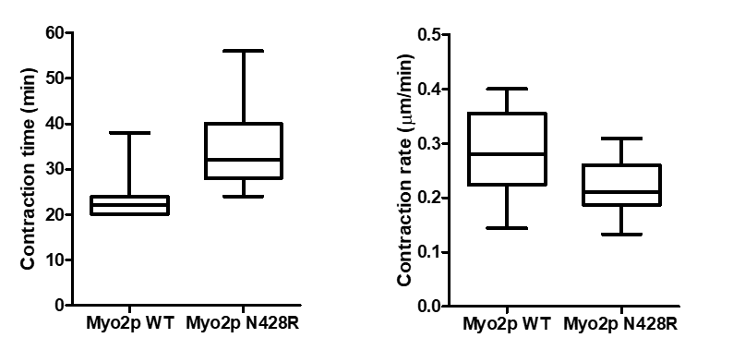

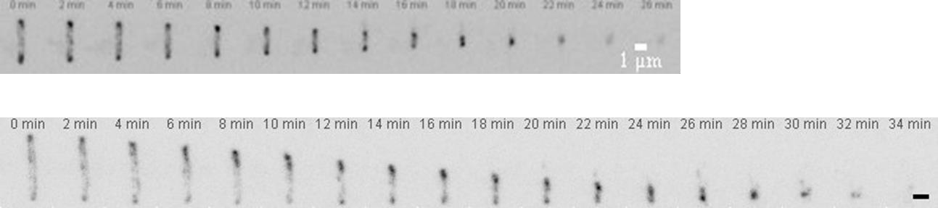


After successfully getting the yeast strains having Myo2p wild type and mutant constructs, we went ahead with cytokinesis acto-myosin ring contraction time lapse imaging studies. As Myo2p is a major motor acto-myosin ring contraction in fission yeast, we wanted to check if mutation affects the ring contraction time and rate. Furthermore, as all the Myo2p constructs are tagged with mNeon Green fluorescent protein, we could use confocal flurescence imaging for the Myo2p visualization in fission yeast cell. Time lapse imaging clearly showed that Myo2p N428R construct strain has about 40% increased ring contraction time and also the 23% decreased ring contraction rate at 24 degree (fig. 3.10).
Figure 3.10 Myo2p wild type and N428R ring contraction studies (a) Montages of ring contraction for mNeon Green tagged Myo2p Wild type and N428R mutant strains at 24 degree Celsius. The scale represents the 1 μm (b) Figure depicts the box plot (2.5-97.5 percentile) for contraction time
and contraction rate for Myo2p wild type (n=12) and N428R strain (n=25). Two biological
a
Myo2p wild
Myo2p N428R
b

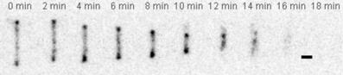
At 36 degree temperature, contraction time for Myo2p N428R mutant is increased by 165%, indicating the strong effect on ring contraction (Figure 13a). Similarly, contraction rate was increased by 64% (Figure 3.11).


a
Myo2p wild type

Myo2p N428R
b
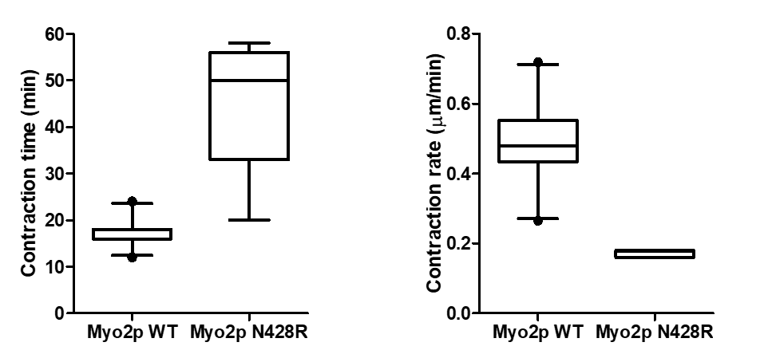

Figure 3.11 Myo2p wild type and N428R ring contraction studies at 36 degree (a) Montages of ring contraction for mNeon Green Myo2p Wild type and N428R mutant strains at 36 degree Celsius. The scale represents the 1 μm (b) Figure depicts the box plot (2.5-97.5 percentile) for contraction time and contraction rate for Myo2p wild type (n=47) and N428R (n=5) strain. Two biological replicates were
performed.

Imaging studies for Myo2p N428C mutation strain

Similar to N428R mutant, we carried out time lapse imaging studies for Myo2p N428C mutant strain. Unexpectedly, this mutant behaved similar to the wild type strain at 24

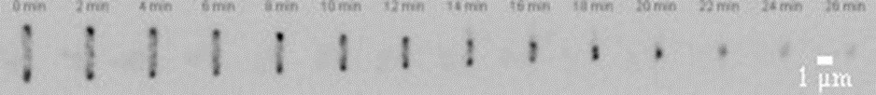

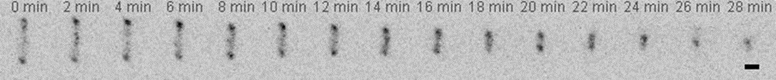
a
Myo2p wild type
Myo2p N428C

b
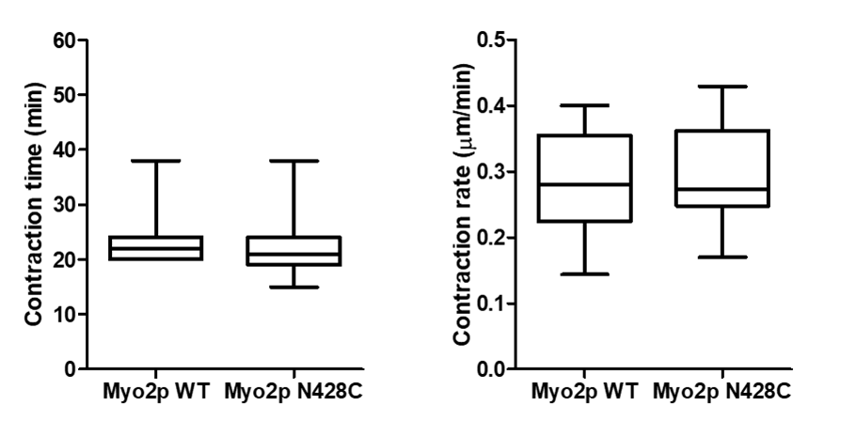

Figure 3.12 Myo2p wild and N428C ring contraction studies. (a) Montages of ring contraction for mNeon Green tagged Myo2p Wild type and N428C mutant strains at 24 degree Celsius. The scale represents the 1 μm (b) Figure depicts the box plot (2.5-97.5 percentile) for contraction time and contraction rate for Myo2p wild type (n=25) and N428R (n=25) strain. Two biological replicates were performed.
degree, showing similar contraction time and rate (Figure 3.12). Interestingly, N428C mutant


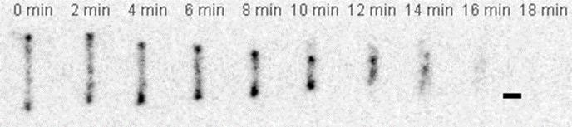

a
Myo2p wild type
Myo2p N428C

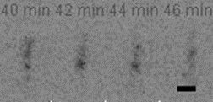
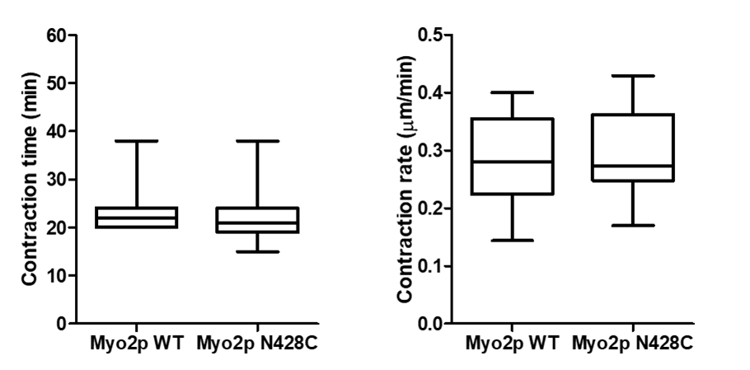

b


Figure 3.13 Myo2p wild and N428C ring contraction studies at 36 degree (a) Montages of ring contraction for mNeon Green tagged Myo2p Wild type and N428C mutant strains at 36 degree Celsius. The scale represents the 1 μm (b) Figure depicts the box plot (2.5-97.5 percentile) for contraction time and
contraction rate for Myo2p wild type (n=43) and N428R (n=18) strain. Two biological replicates were

strain showed phenotype at 36 degree temperature, showed increase in contraction time by 58% and decrease in contraction rate by 55%.

In-vitro ring contraction study

In vivo studies showed us the effect of mutation on cytokinesis ring contraction time and rate. To study if this results remains consistent with the in vitro studies also we went ahead with the in vitro ring contraction study. Cytokinesis rings were purified from Myo2p wild type, Myo2p N428R and N428C mutants. Unfortunately, we faced technical difficulties with ring contraction studies like losing a focus, imaging stage movement hence we couldn’t complete the in vitro ring contraction studies for mutants with in time frame of thesis. Still, we managed to see the contraction of Myo2p wild type purified ring.
Figure 3.14 Myo2p wild type in vitro ring contraction Montage of Myo2p in nitro cytokinesis ring

Chapter 4 - Discussions

The residue connection pathway elucidated through our study clearly showed how residues play a crucial role in the global allostery of myosin. Many of the residues in the connection pathway are highly conserved and the contact among them is maintained throughout the conformational transitions of ATPase cycle. Perhaps, more than a residue, it’s the connectivity of contact that is essential which establishes the communication. Such a thorough analysis of allostery to the residue was possible because of our comprehensive structural analysis approach.
The top to bottom approach, going from subdomain conformational changes to the constituent secondary structure movements is computationally inexpensive and allows comparison across a large number of structures. The present day computational methods such as Molecular Dynamics Simulation, Normal Mode Analysis and Principle Component Analysis allows a rigorous analysis of conformational changes to the level of atoms but they demand a high quality of crystal structures. Such a high cost demand could be overcome by our method.

Along with many advantages, our method also brought new insights to the myosin research field. Until now many myosin inhibitors like pseudilin, blebbistatin, and omecative mecarbil are known to affect the actin binding and force generation. Pseudilins and blebbistatin decrease the actin affinity whereas omecative mecarbil increases the actin affinity (Allingham et al., 2005; Bond et al., 2013). These inhibitors are known to alter local residue interactions and conformational changes. Hence, we thought inhibitor binding may also affect the movement of nearby secondary structures. But none of the secondary structures from inhibitor bound structures showed alterations in the movement through secondary structure kappa plot.

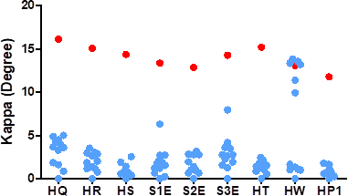
Figure 4.1. Kappa angle plot for ddmyoII L50 subdomain secondary structures.

Unlike pseudulin inhibitor which binds in the U50 subdomain only, blebbistatin inhibitor binds in the actin binding cleft, the interface between U50 and L50 subdomains. As we did not get deviation in the secondary structure movement of U50 subdomain so,
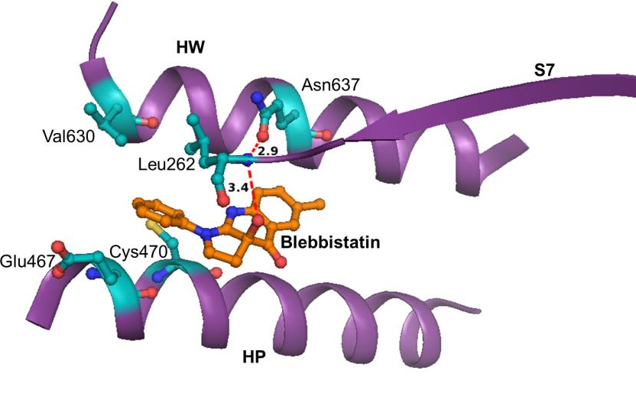

Figure 4.2 Interactions between blebbistatin and residues from HW, S7 and HP helix. Asn637 (HW) has interactions with blebbistatin through Leu262 (S7) residue. Other depicted residues have Van der Waals interactions with blebbistatin. (1YV3 PDB code of myosin structure)

we went on to calculate the movement of L50 subdomain secondary structures by using spherical polar angles during PPS to Rigor state transition. The Kappa plot for the L50 subdomain secondary structures showed that among many other L50 subdomain secondary structures HW helix stood out (Figure 4.1). The structures captured in blebbistatin bound form showed higher shift in the kappa value compared to the other PPS state structures. These structures were 1YV3, 3MYH, 3MYK, 3BZ7, 3BZ8 and 3BZ9. The shift in the HW kappa angle clearly signifies that blebbistatin binding majorly affects the HW helix movement. HW movement happens in response to the weak actin interactions which promotes PPS to rigor state transition for the stronger actin binding (Preller and Manstein, 2013). Previous structural studies have shown that blebbistatin makes interactions with the HW, HP and S7 strands, but HP and S7 strand did not show deviation in the Kappa values whereas, HW helix showed, thereby we could conclude through our study that even though blebbistatin has a number of interactions with S7, HP, and HW helix but it specifically inhibits the HW helix motion (Figure 4.2).
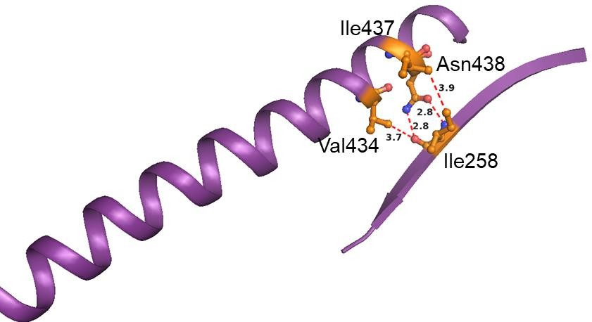
Figure 4.3. Interactions between HO and S7B strand

The validation of crucial residue N438 highlighted from our study in fission yeast supported the residue connection pathway. N438R mutation indeed showed phenotype at both 24 degree and 36 degree temperature. Moreover, temperature sensitive behaviour of N438C mutant further supported our communication pathway where interconnectivity of residues is maintained in temperature dependent manner. Surprisingly, our mutant N438R and N438C did not stronger phenotype compared to Myo2E1 mutant which increases contraction time around 300% (Palani et al., 2017). G341R mutation in Myo2E1 case introduces a steric hindrance in U50 kDa subdomain

(Palani et al., 2018). Thus, the mutation may disrupt a number of residue interactions which could be important for myosin to function.
In the case of our mutants, we have just disrupted contact at one location between N438 and I258 residue. Further closer analysis of local residue interaction between S7B and HO helix interaction we found many other Van der Waals interactions between Ile258 (S7B) and Val434 and Ile437 (HO) secondary structure (Figure 4.3). Hence, these sustained interaction between HO and S7B strand may keep the allosteric communication pathway functional even after the mutation. Maybe upon double mutation of N438 and IleA258 we could get strong phenotype like Myo2E1 mutant.
Though Myo2p is a major motor in acto-myosin ring contraction in fission yeast, there are other myosins also present at the contractile ring, namely Myp2p and Myo51 (Win et al., 2002). It would be interesting to see the behaviour of our Myo2p wild type and mutants in the background of Myp2p and Myo51 deletion. Mutation in Myo2p may affect its bio physicochemical properties and protein folding. Furthermore, inefficient protein folding due mutation may affect the expression levels of Myo2p in fission yeast cell. So, it is important to check the protein expression levels through western blot. The rng3 (UCS-domain protein) and Hsp90 proteins are known to facilitate the Myo2p motor domain folding (Hutagalung, 2002). Rng3 protein is also known to increase the Myo2p activity like actin gliding motility and ATPase activity in an in vitro system (Lord and Pollard, 2004). Hence, it is crucial to study the biochemical properties of Myo2p in in vitro system. Until now, we used acto-myosin ring contraction time and rate as proxy for defective myosin function upon mutation. But, still, we are unaware of the fact of how mutation is affecting the myosin function. In vitro studies would help us to dissect the effect of the mutation on myosin.

Chapter 5 - Conclusions

In the study presented here, the comprehensive structural analysis allowed us to predict the residue connection pathway from the active site to the actin binding region. Every residue in the connection pathway showed sustained contact among them, which is essential for myosin to function. Importance of this connection was further validated through mutation study on Myo2p protein in fission yeast. Myo2p protein is a major
motor protein involved in cytokinesis ring contraction protein showed slower ring constriction upon mutagenesis. Furthermore, temperature sensitive mutation gave strong support to the residue connection pathway, as we could tune the connection pathway in a temperature dependent manner. In all, a combination of computational and experimental work allowed us to go from molecular level to the organismal level in order to study allosteric conformational changes in the myosin head domain.

Chapter 6- References

Allingham, J.S., Smith, R., and Rayment, I. (2005). The structural basis of blebbistatin inhibition and specificity for myosin II. Nature Structural and Molecular Biology.

Ashkenazy, H., Abadi, S., Martz, E., Chay, O., Mayrose, I., Pupko, T., and Ben-Tal,
N. (2016). ConSurf 2016: an improved methodology to estimate and visualize evolutionary conservation in macromolecules. Nucleic Acids Research.

Bateman, A., Martin, M.J., O’Donovan, C., Magrane, M., Alpi, E., Antunes, R., Bely, B., Bingley, M., Bonilla, C., Britto, R., et al. (2017). UniProt: The universal protein knowledgebase. Nucleic Acids Research.

Bond, L.M., Tumbarello, D.A., Kendrick-Jones, J., and Buss, F. (2013). Small- molecule inhibitors of myosin proteins. Future Medicinal Chemistry.

Chinthalapudi, K., Heissler, S.M., Preller, M., Sellers, J.R., and Manstein, D.J. (2017). Mechanistic insights into the active site and allosteric communication pathways in human nonmuscle myosin-2C. ELife.

Colegrave, M., and Peckham, M. (2014). Structural implications of β-cardiac myosin heavy chain mutations in human disease. Anatomical Record.

Coureux, P.D., Wells, A.L., Ménétrey, J., Yengo, C.M., Morris, C.A., Sweeney, H.L., and Houdusse, A. (2003). A structural state of the myosin V motor without bound nucleotide. Nature.

Evans, P.R. (2001). Rotations and rotation matrices. Acta Crystallographica - Section D Biological Crystallography.

Geeves, M.A., and Holmes, K.C. (2005). The molecular mechanism of muscle
contraction. Advances in Protein Chemistry.

Hodge, T., Cope, M.J.T. V., Jamie, M., and Cope, T. V (2000). A myosin family tree. Journal of Cell Science.

Holm, L., and Laakso, L.M. (2016). Dali server update. Nucleic Acids Research.

Houdusse, A., and Sweeney, H.L. (2016). How Myosin Generates Force on Actin Filaments. Trends in Biochemical Sciences.

Hutagalung, A.H. (2002). The UCS family of myosin chaperones. Journal of Cell Science.

Huxley, H., and Hanson, J. (1954). Changes in the Cross-striations of muscle during contraction and stretch and their structural interpretation. Nature.

Kühne, W. (2011). Untersuchungen über das Protoplasma und die Contractilität / von W. Kühne.

Llinas, P., Isabet, T., Song, L., Ropars, V., Zong, B., Benisty, H., Sirigu, S., Morris, C., Kikuti, C., Safer, D., et al. (2015). How Actin Initiates the Motor Activity of Myosin. Developmental Cell.

Lord, M., and Pollard, T.D. (2004). UCS protein Rng3p activates actin filament gliding by fission yeast myosin-II. Journal of Cell Biology.

Lymn, R.W., and Taylor, E.W. (1971). Mechanism of Adenosine Triphosphate Hydrolysis by Actomyosin. Biochemistry.

Nag, S., Trivedi, D. V., Sarkar, S.S., Adhikari, A.S., Sunitha, M.S., Sutton, S., Ruppel, K.M., and Spudich, J.A. (2017). The myosin mesa and the basis of hypercontractility caused by hypertrophic cardiomyopathy mutations. Nature Structural and Molecular Biology.

Oldfors, A., Tajsharghi, H., Darin, N., and Lindberg, C. (2004). Myopathies associated with myosin heavy chain mutations. Acta Myologica.

Palani, S., Chew, T.G., Ramanujam, S., Kamnev, A., Harne, S., Chapa-y-Lazo, B., Hogg, R., Sevugan, M., Mishra, M., Gayathri, P., et al. (2017). Motor Activity Dependent and Independent Functions of Myosin II Contribute to Actomyosin Ring Assembly and Contraction in Schizosaccharomyces pombe. Current Biology.

Palani, S., Gayathri, P., Balasubramanian, M.K., Kamnev, A., Zambon, P., and Srinivasan, R. (2018). Steric hindrance in the upper 50 kDa domain of the motor Myo2p leads to cytokinesis defects in fission yeast. Journal of Cell Science.

Pestic-Dragovich, L., Stojiljkovic, L., Philimonenko, A.A., Nowak, G., Ke, Y., Settlage, R.E., Shabanowitz, J., Hunt, D.F., Hozak, P., and De Lanerolle, P. (2000). A myosin I isoform in the nucleus. Science.

Pollard, T.D., and Wu, J.Q. (2010). Understanding cytokinesis: Lessons from fission yeast. Nature Reviews Molecular Cell Biology.

Preller, M., and Manstein, D.J. (2013). Myosin structure, allostery, and mechano- chemistry. Structure.

Preller, M., Bauer, S., Adamek, N., Fujita-Becker, S., Fedorov, R., Geeves, M.A., and Manstein, D.J. (2011). Structural basis for the allosteric interference of myosin function by reactive thiol region mutations G680A and G680V. Journal of Biological Chemistry.

Rayment, I., Rypniewski, W.R., Schmidt-Bäse, K., Smith, R., Tomchick, D.R., Benning, M.M., Winkelmann, D.A., Wesenberg, G., and Holden, H.M. (1993). Three- dimensional structure of myosin subfragment-1: A molecular motor. Science.

Spudich, J.A. (2015). The myosin mesa and a possible unifying hypothesis for the molecular basis of human hypertrophic cardiomyopathy. Biochemical Society Transactions.

Vale, R.D., and Milligan, R.A. (2000). The way things move: Looking under the hood of molecular motor proteins. Science.

Vicente-Manzanares, M., Ma, X., Adelstein, R.S., and Horwitz, A.R. (2009). Non- muscle myosin II takes centre stage in cell adhesion and migration. Nature Reviews Molecular Cell Biology.

Vreugde, S., Ferrai, C., Miluzio, A., Hauben, E., Marchisio, P.C., Crippa, M.P., Bussi, M., and Biffo, S. (2006). Nuclear Myosin VI Enhances RNA Polymerase II- Dependent Transcription. Molecular Cell.

Win, T.Z., Mulvihill, D.P., and Hyams, J.S. (2002). Take five: A myosin class act in fission yeast. Cell Motility and the Cytoskeleton.

Yamamoto, K., Hamada, S., and Kashiyama, T. (1999). Myosins from plants. Cellular and Molecular Life Sciences.

Yang, Y., Gourinath, S., Kovács, M., Nyitray, L., Reutzel, R., Himmel, D.M., O’Neall- Hennessey, E., Reshetnikova, L., Szent-Györgyi, A.G., Brown, J.H., et al. (2007).
Rigor-like Structures from Muscle Myosins Reveal Key Mechanical Elements in the Transduction Pathways of This Allosteric Motor. Structure.

Yang, Y., Yu, H., and Cui, Q. (2008). Extensive Conformational Transitions Are Required to Turn On ATP Hydrolysis in Myosin. Journal of Molecular Biology.

Zambon, P., Palani, S., Kamnev, A., and Balasubramanian, M.K. (2017). Myo2p is the major motor involved in actomyosin ring contraction in fission yeast. Current Biology.

